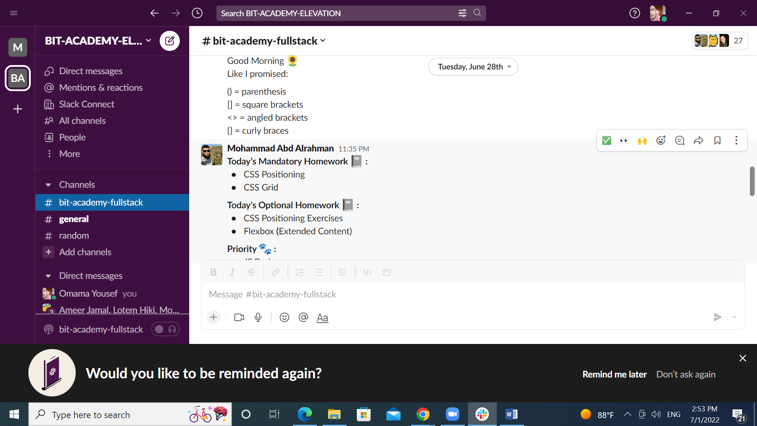

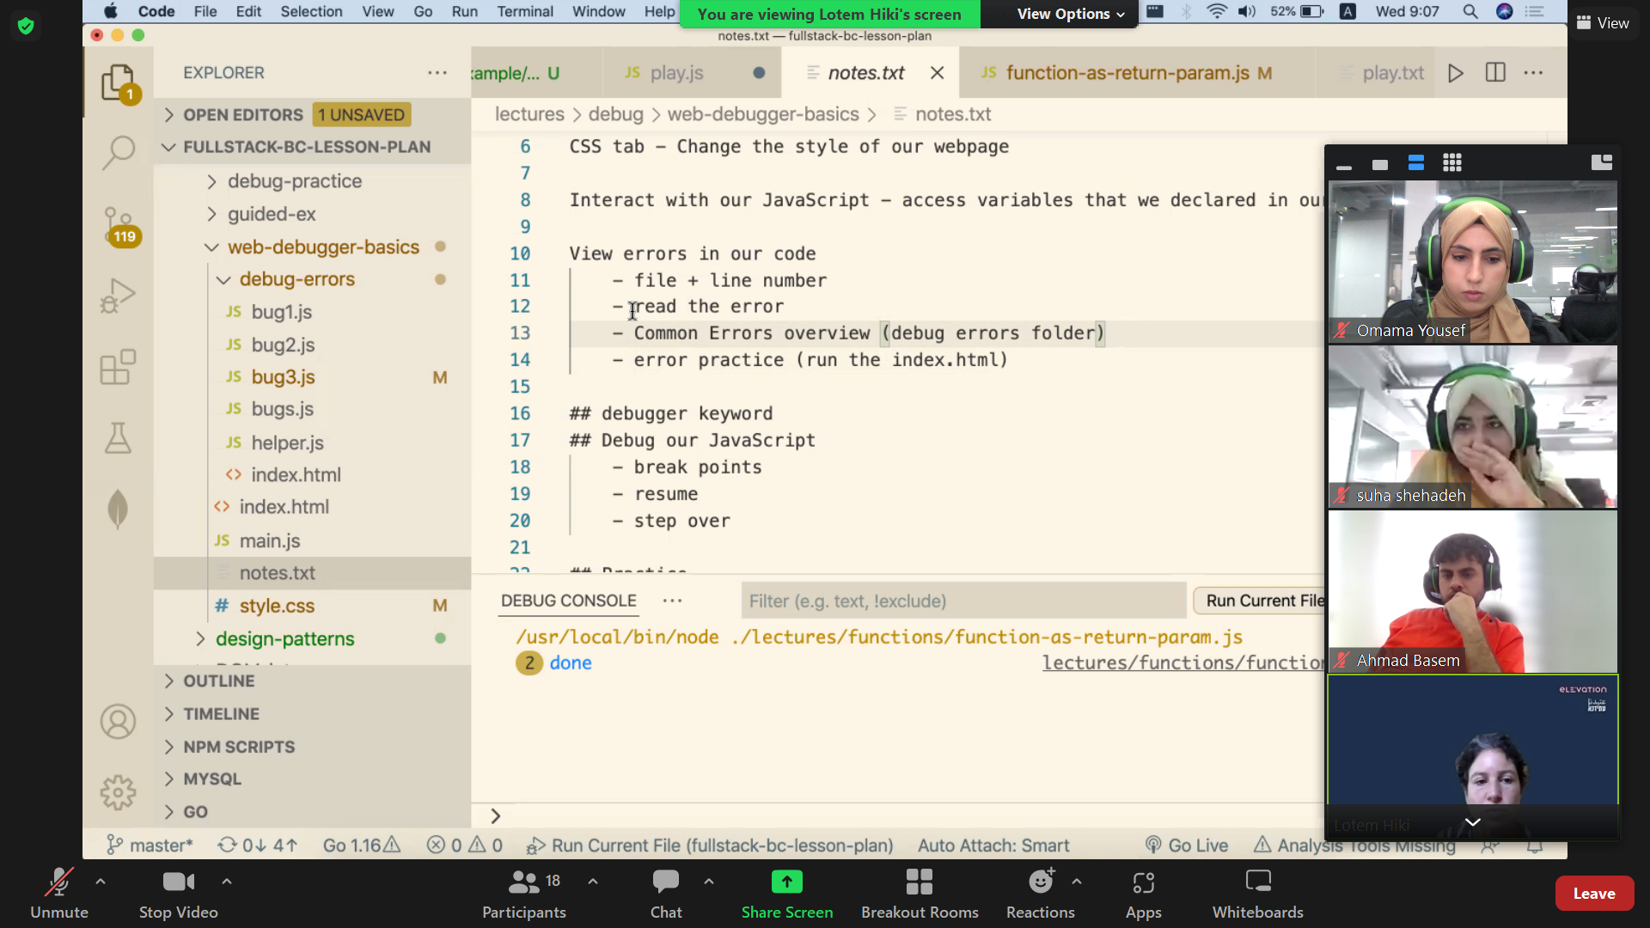

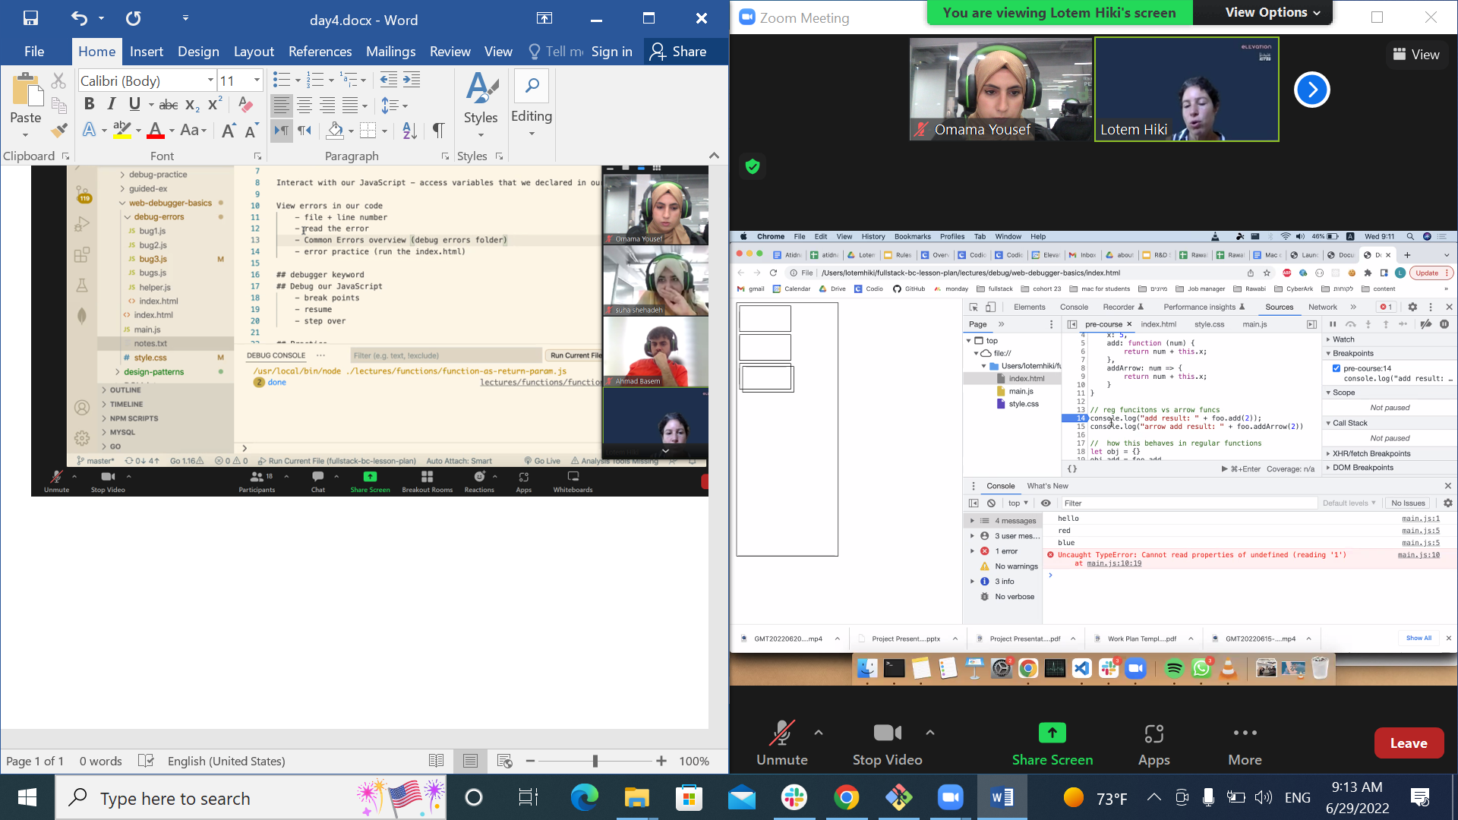

Why I should move to new -🡪

Line by line is good but the best way is …..

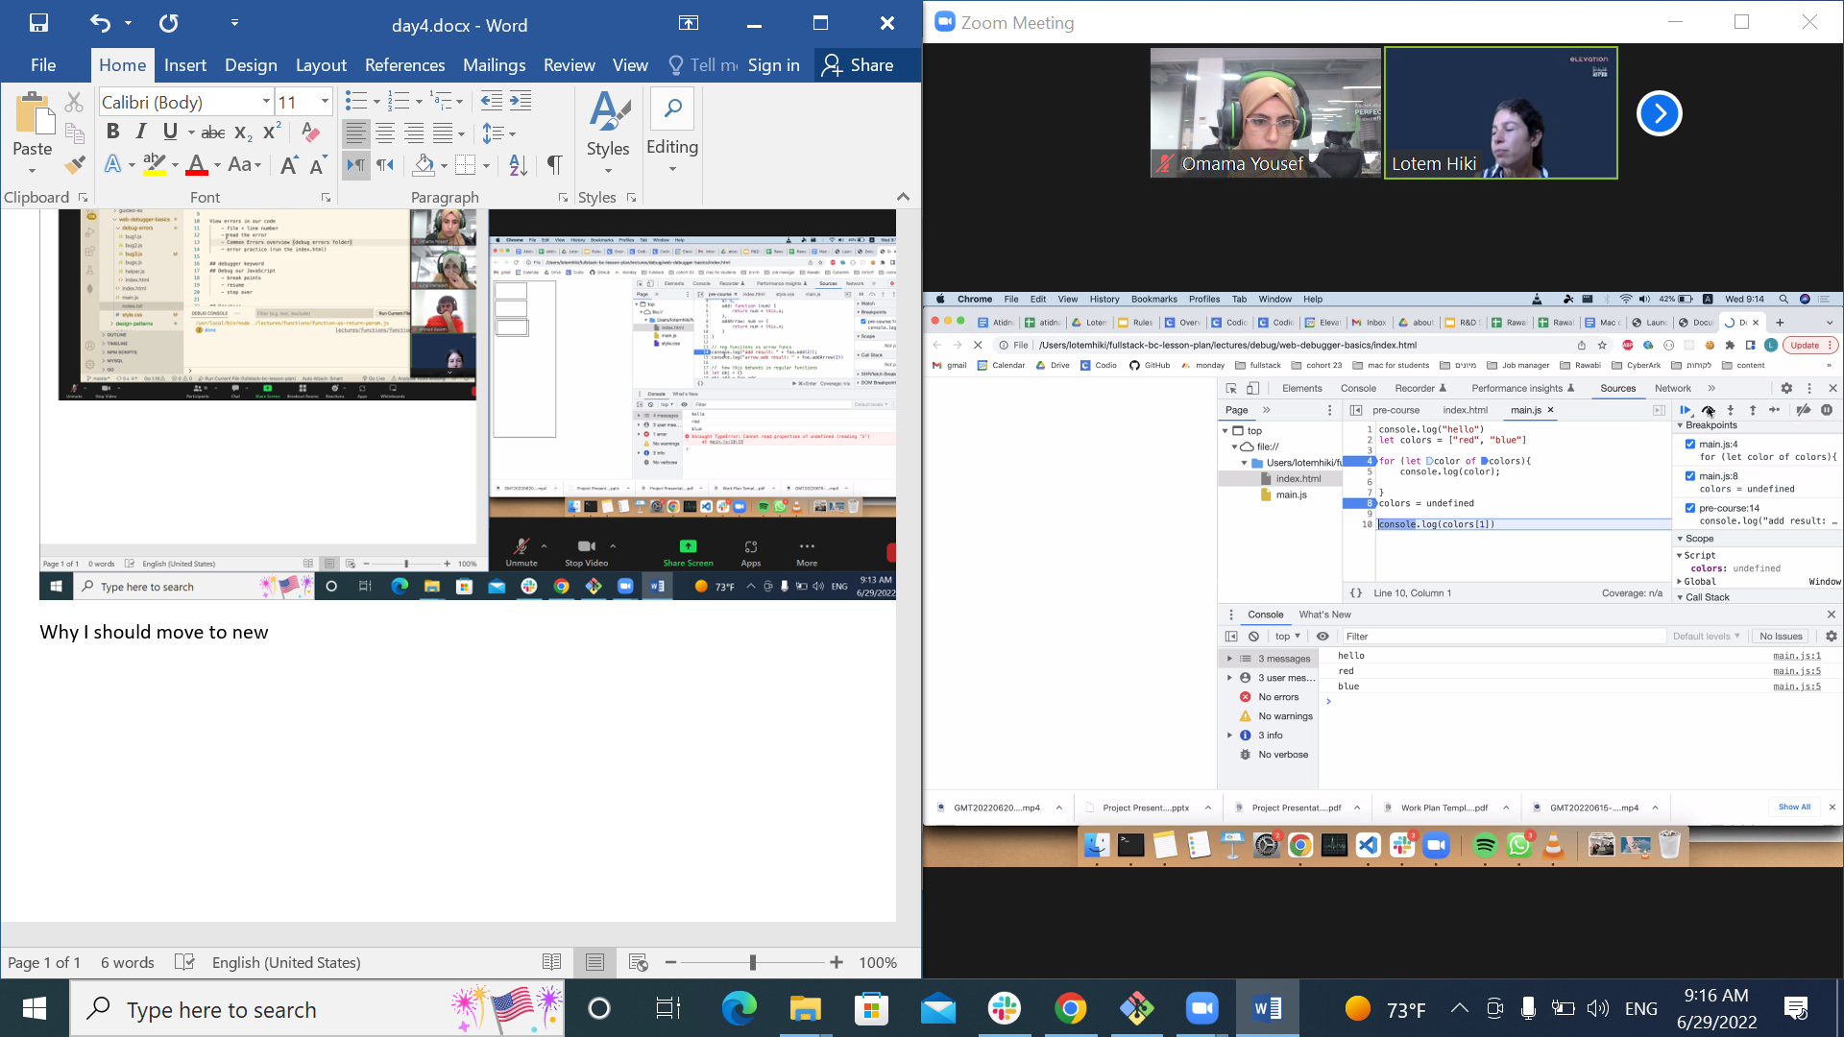

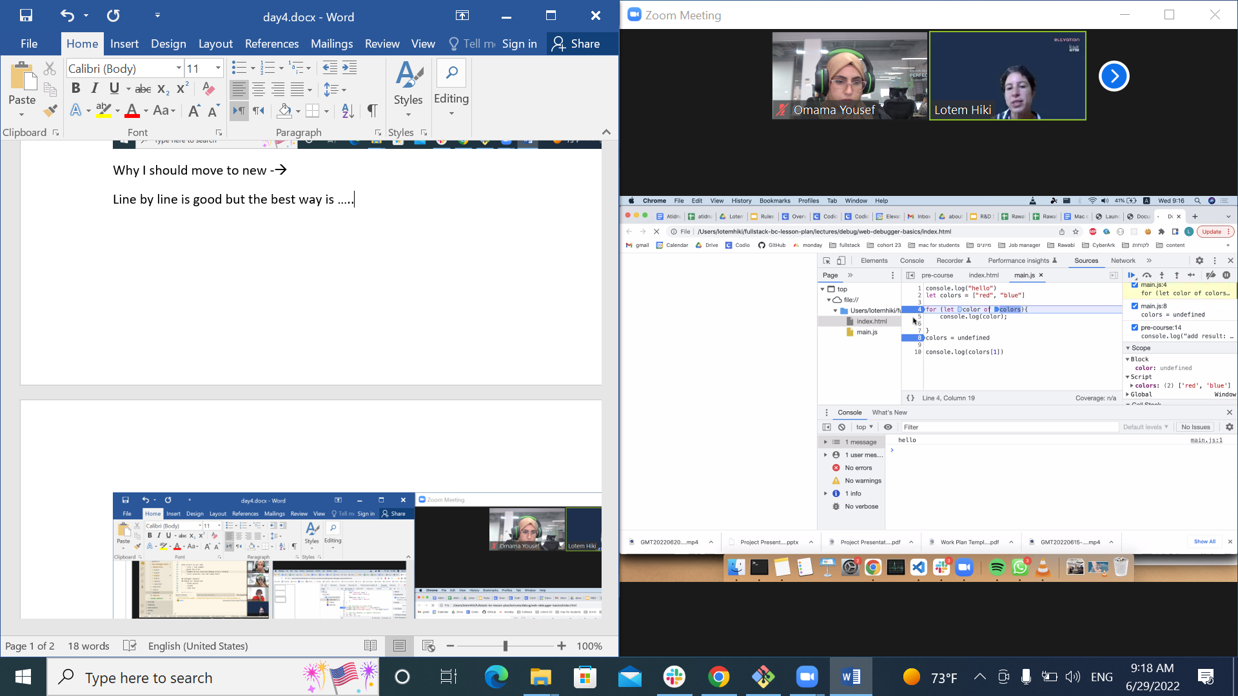

Step over

How to

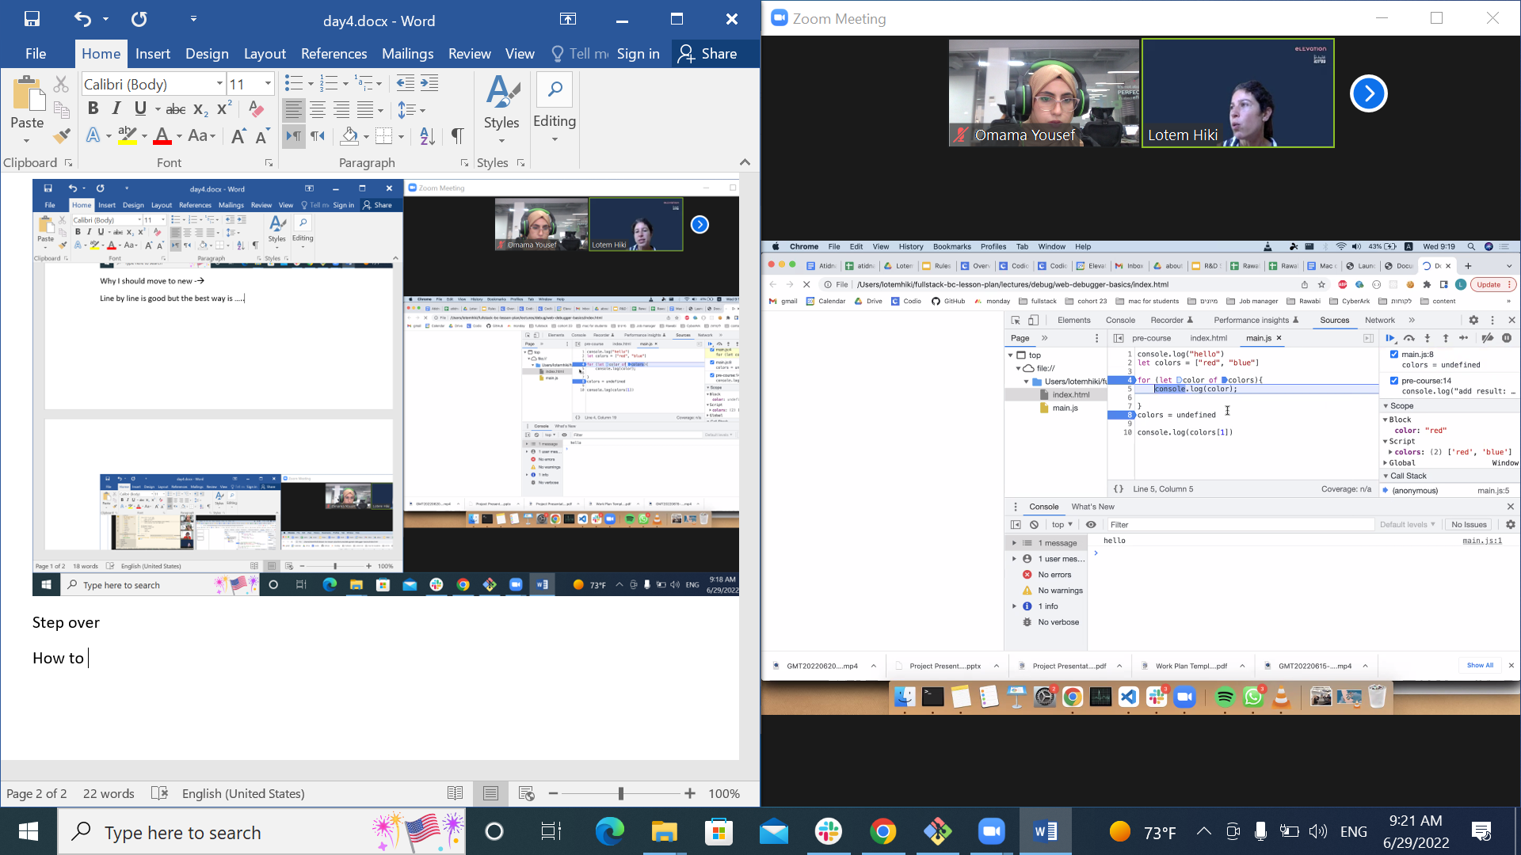

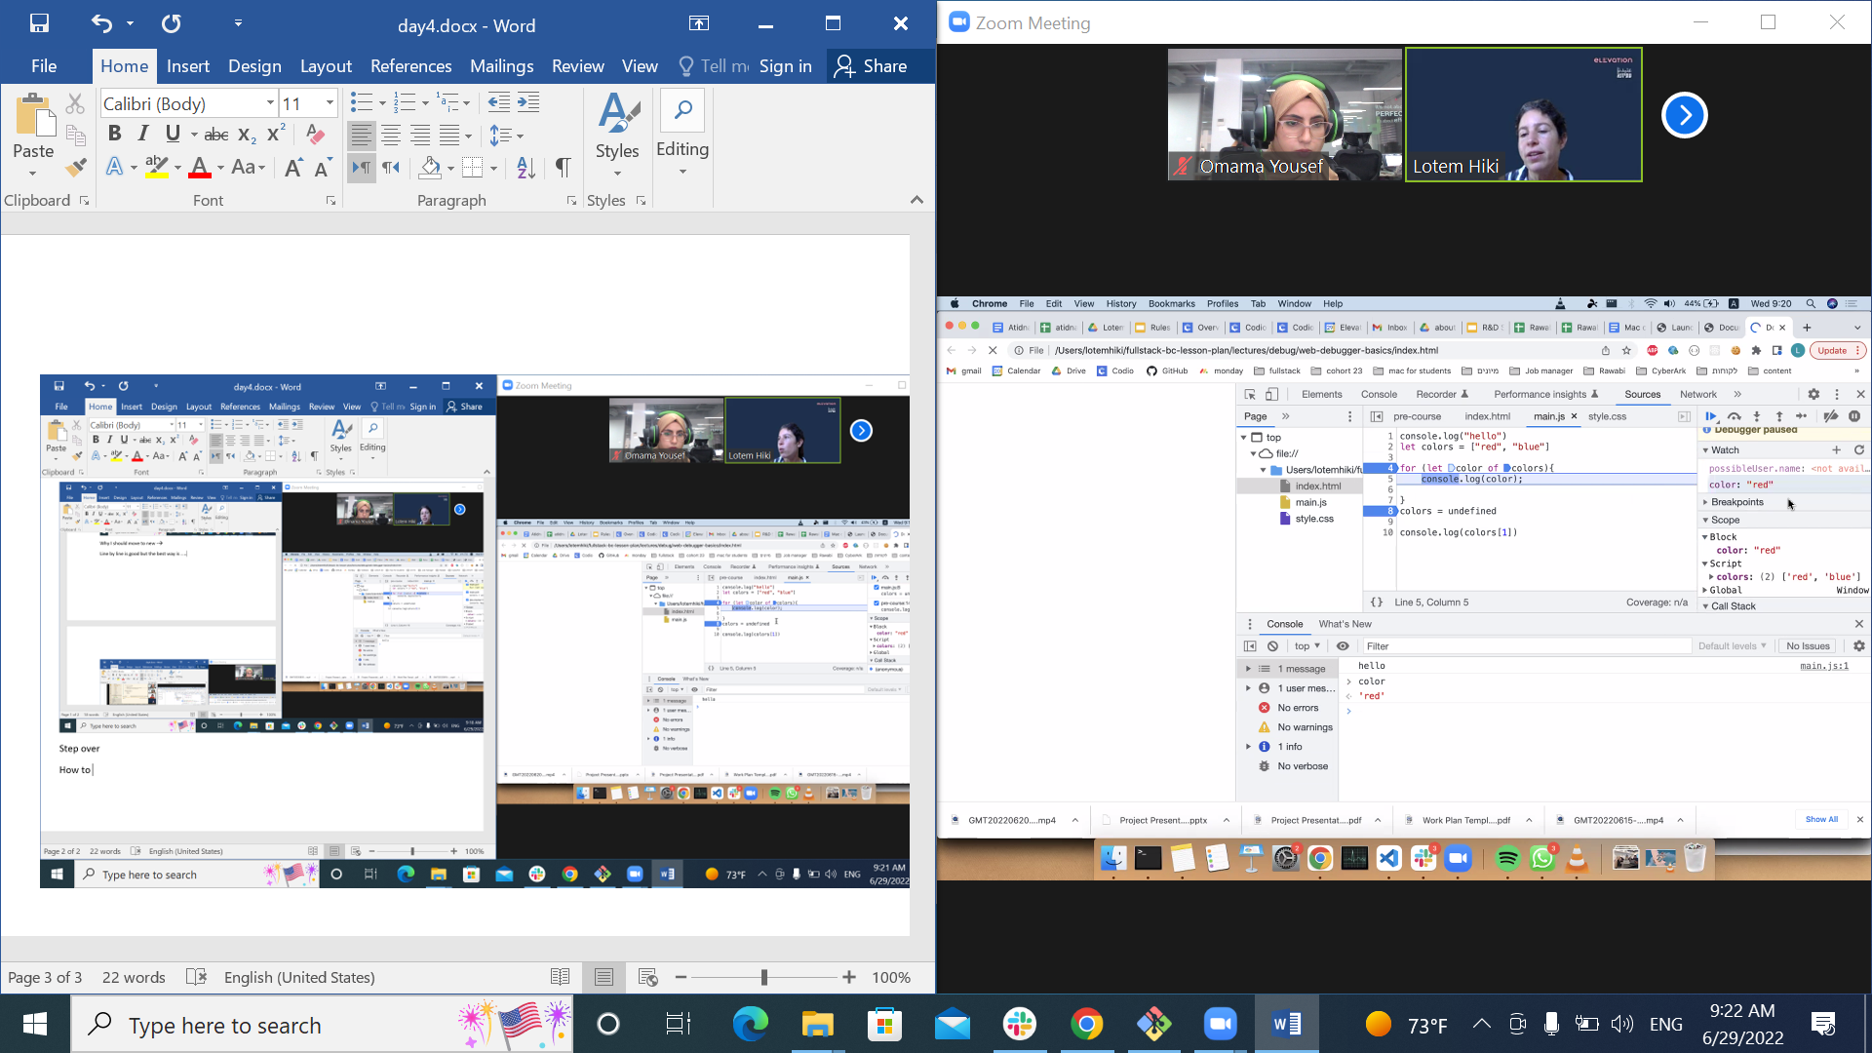

**When I go to watch method I add the name of var and print hover when I add**

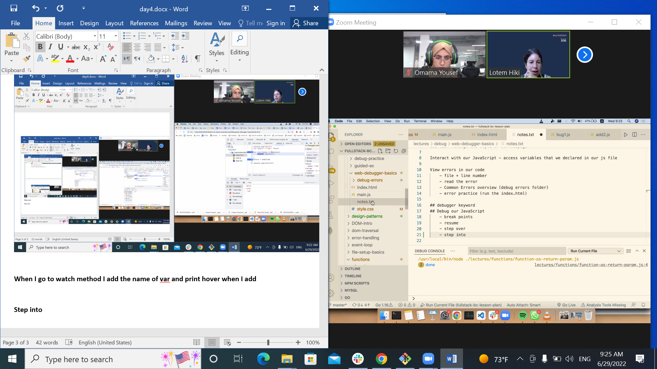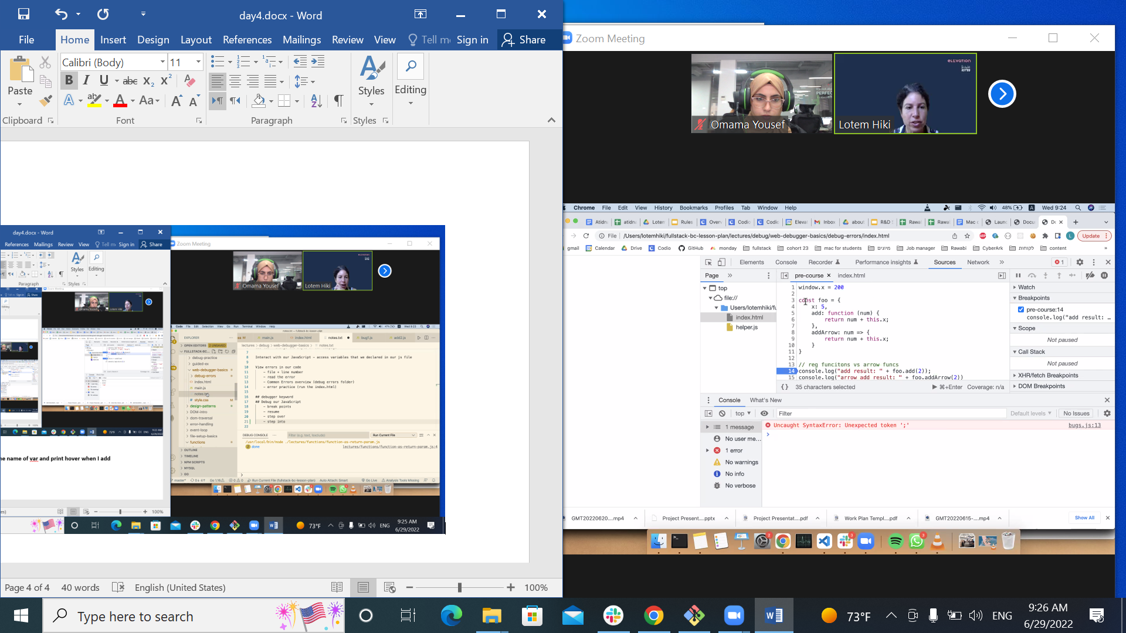

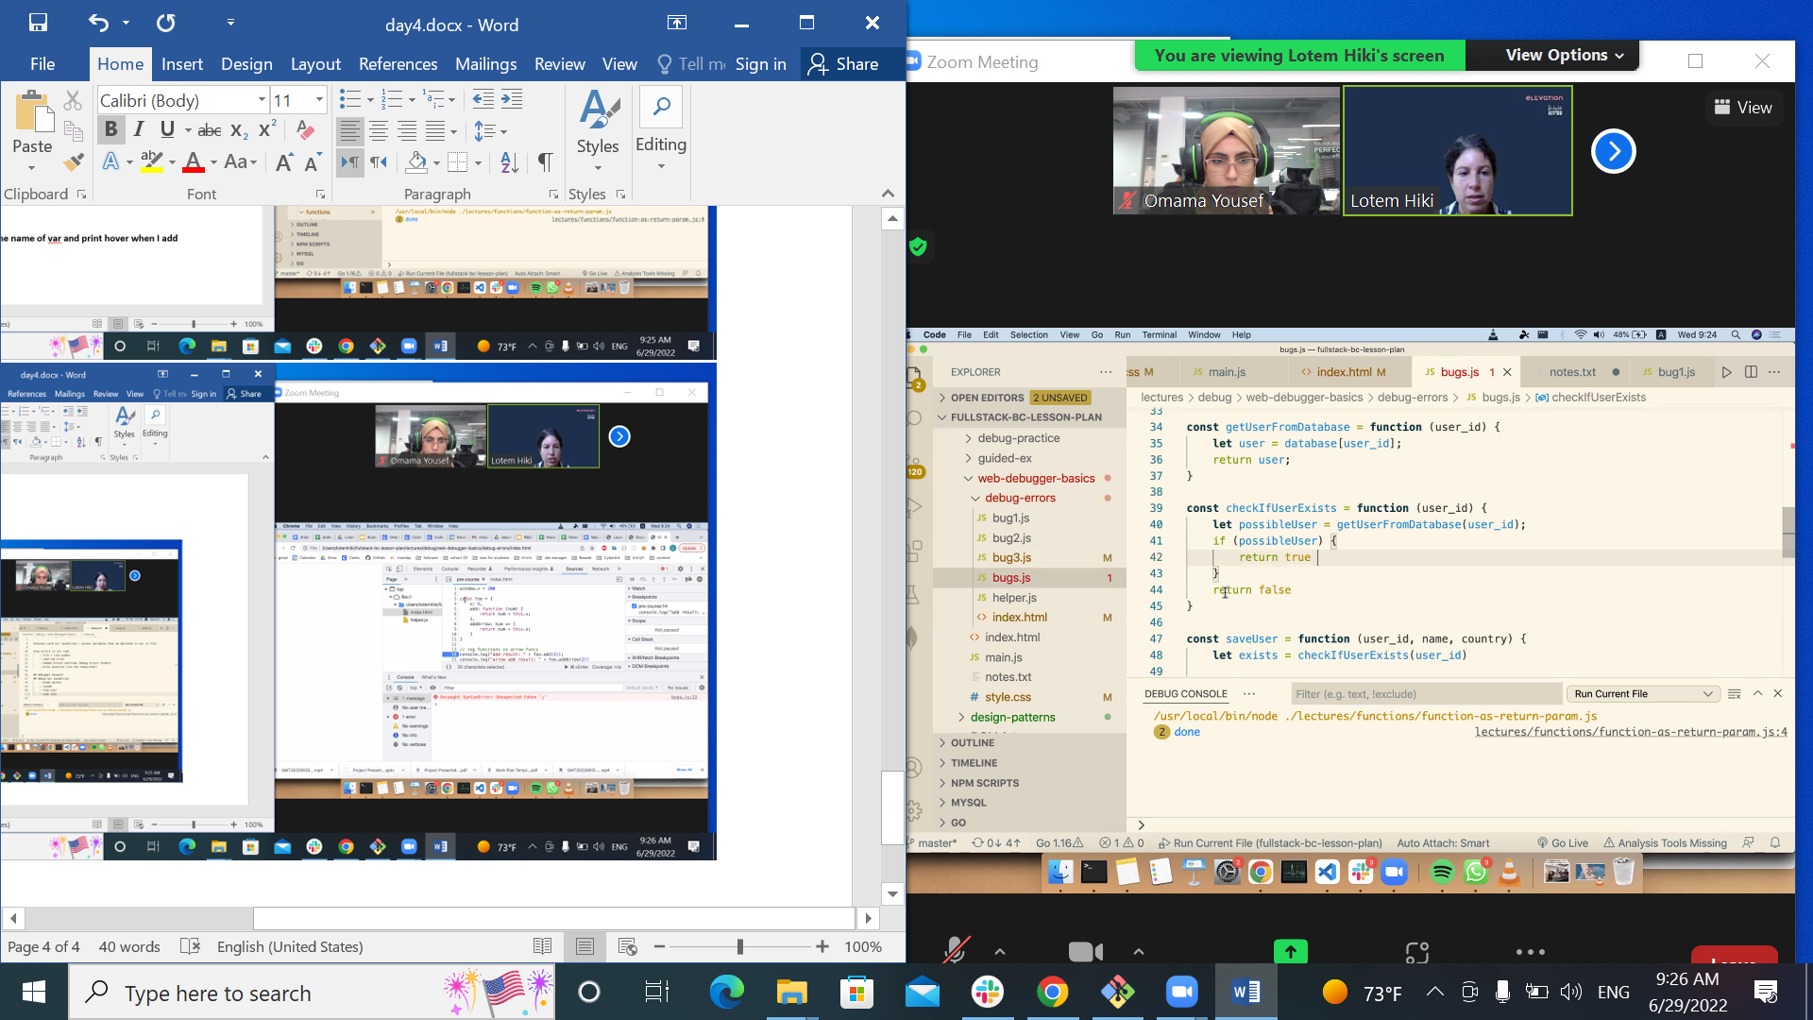

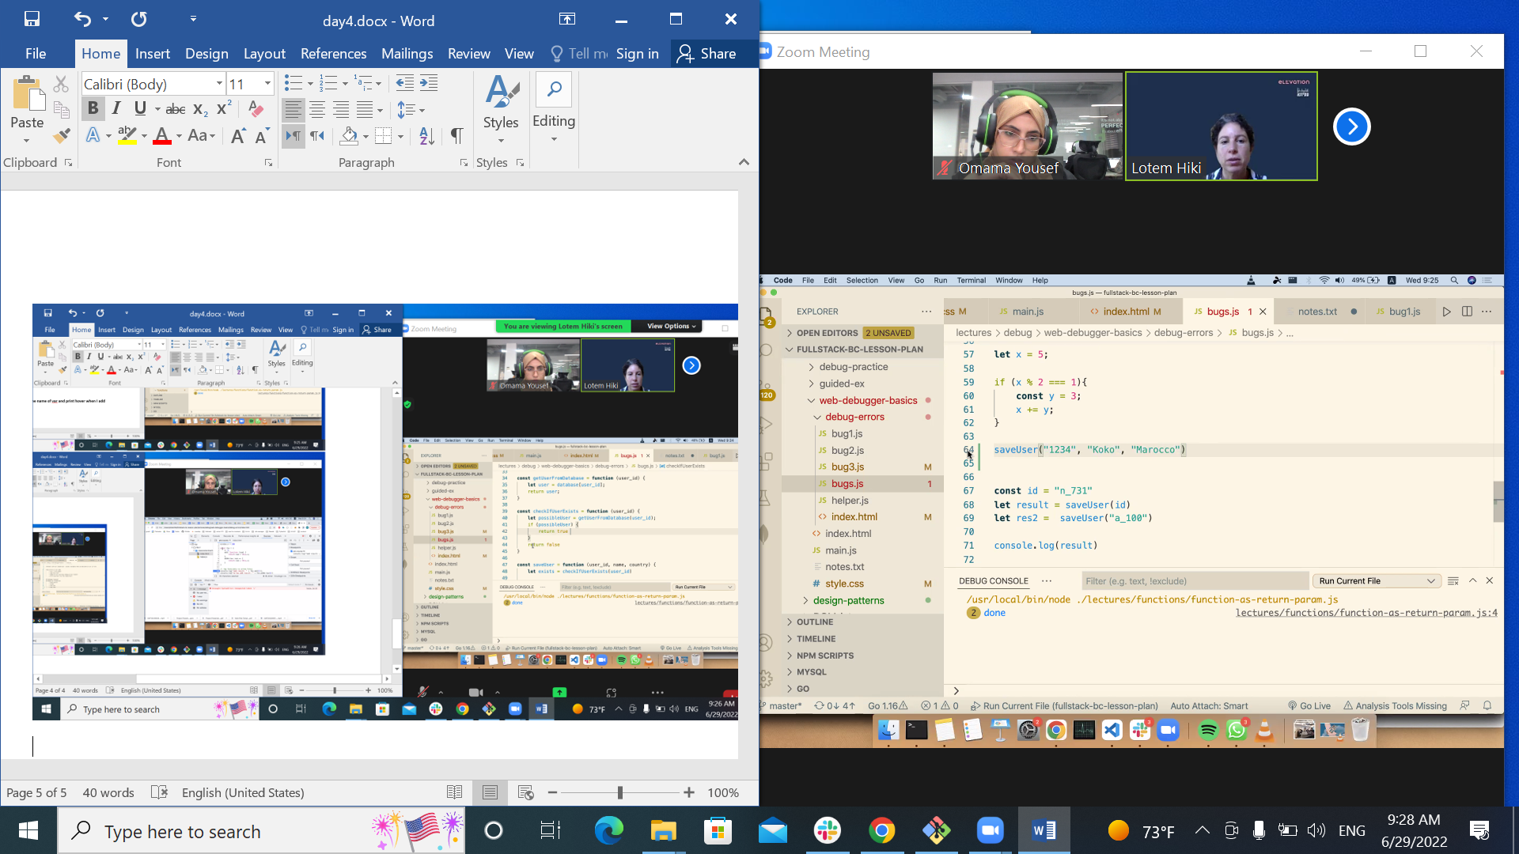

**Full stack**

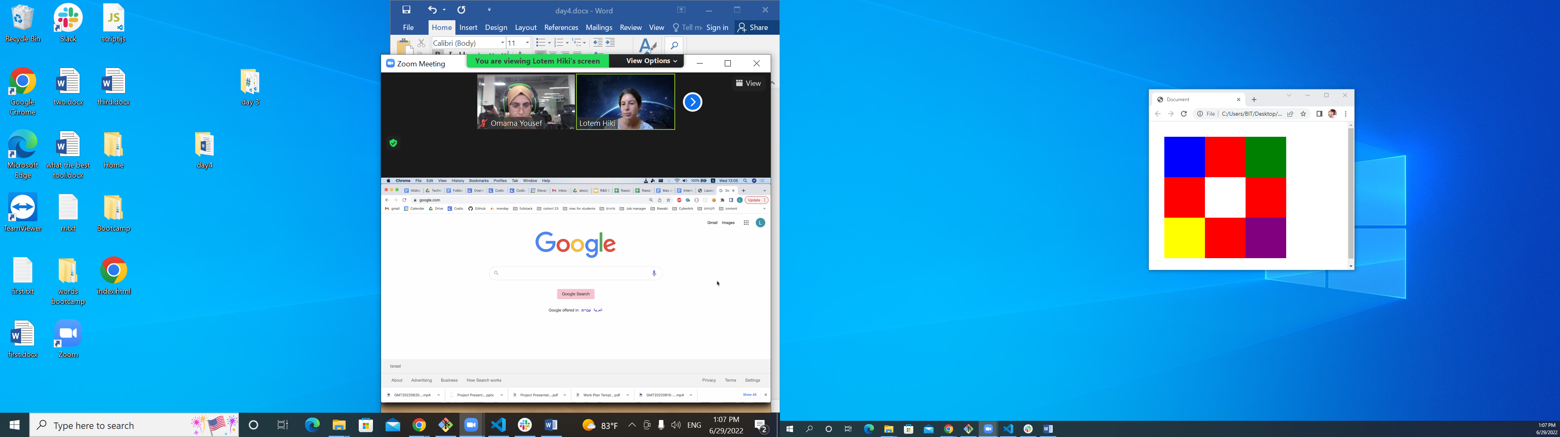

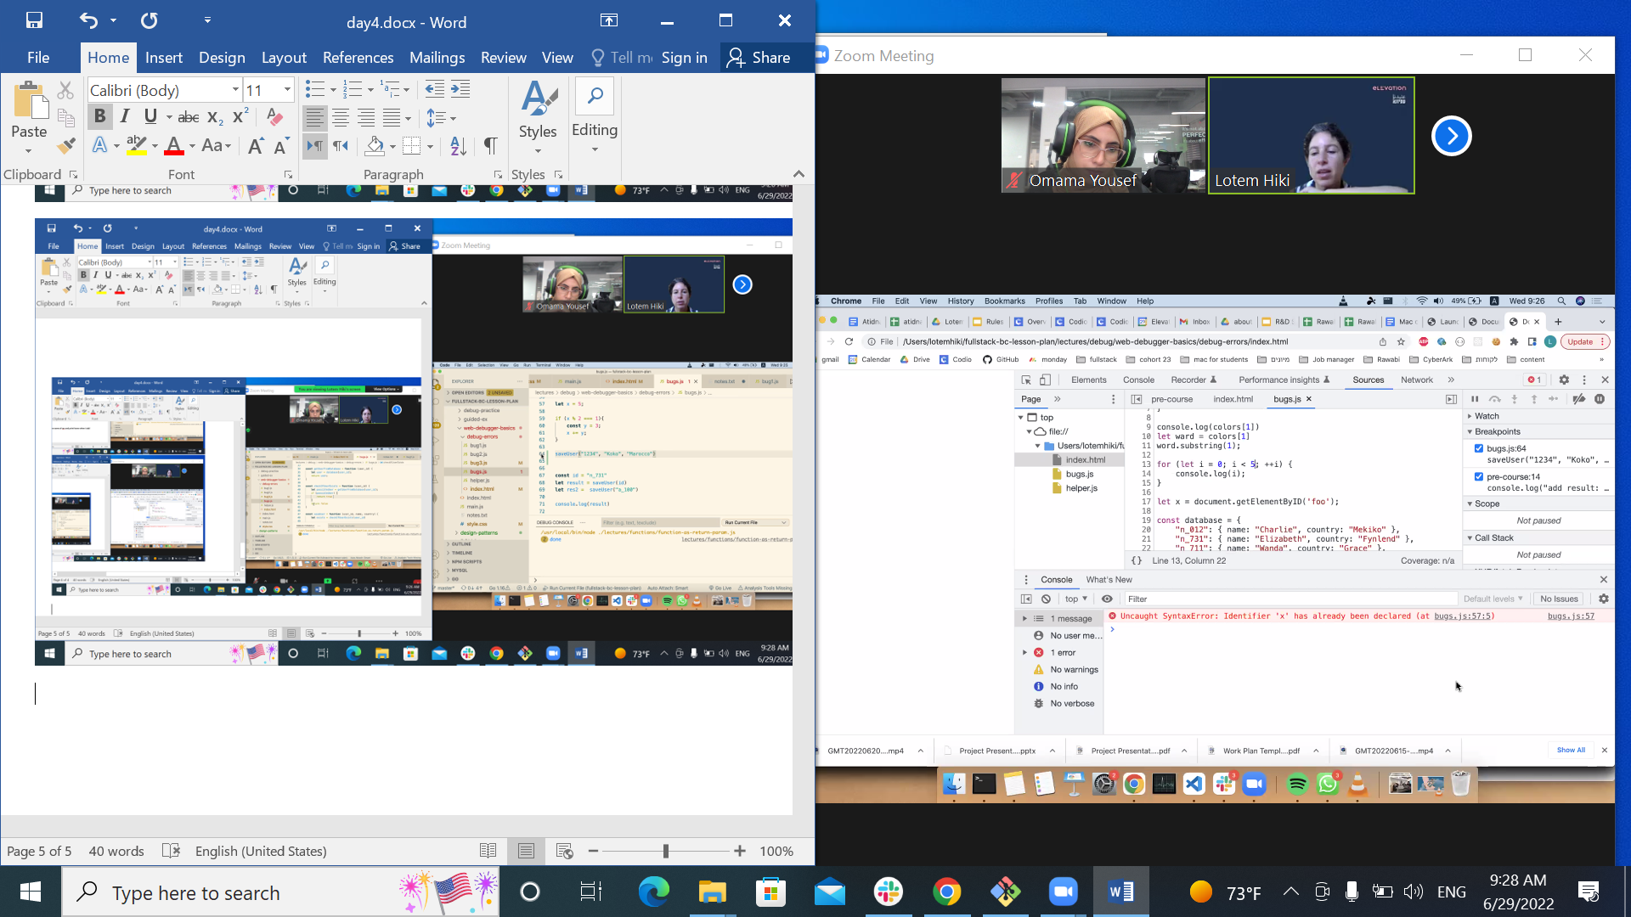

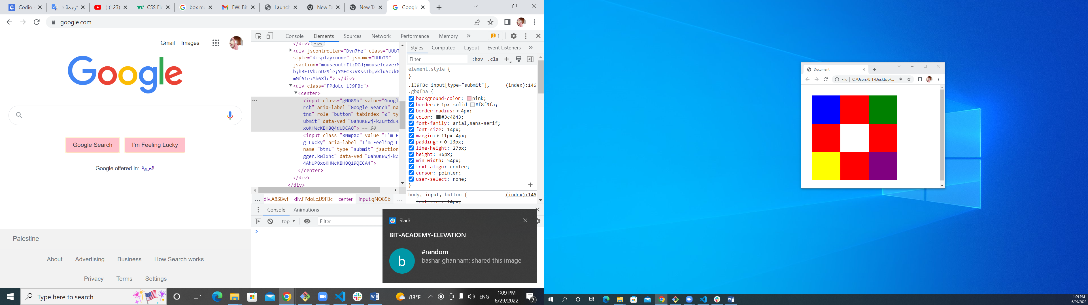

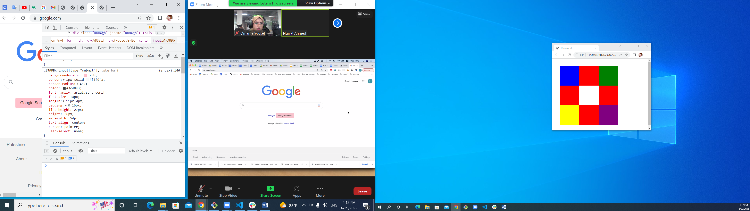

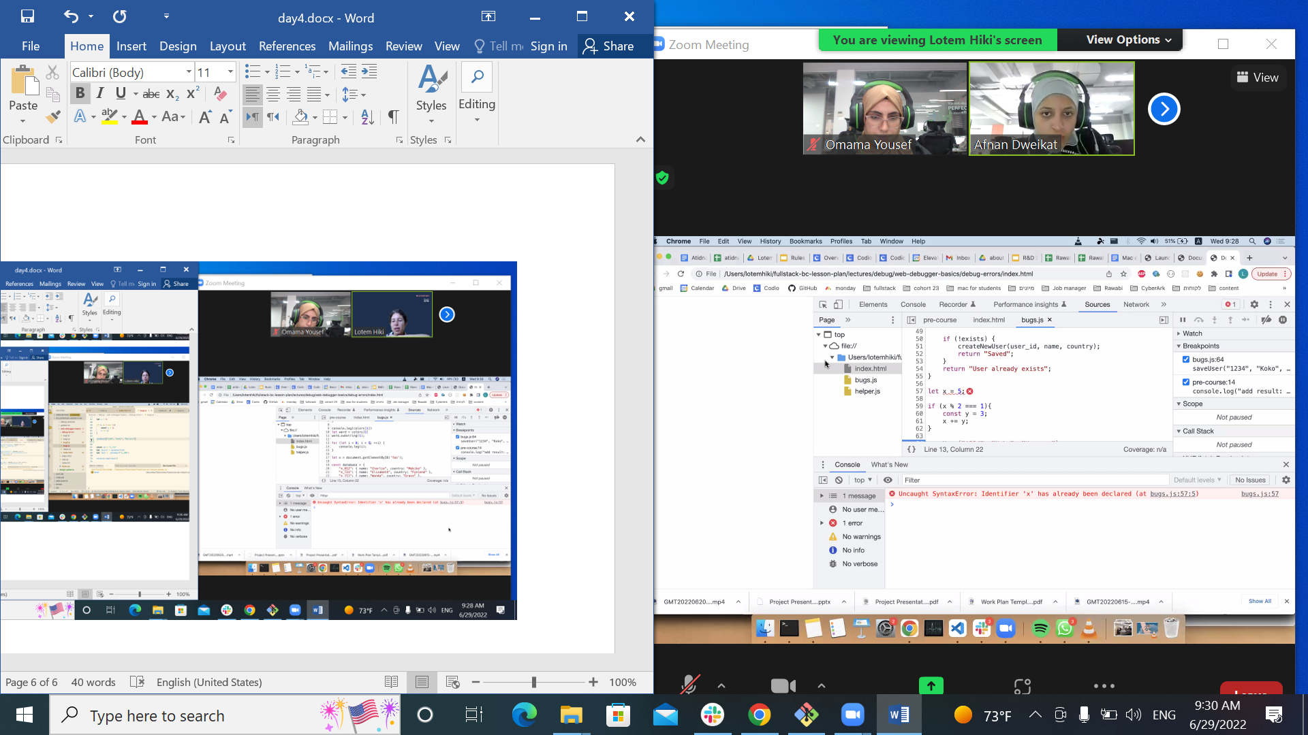

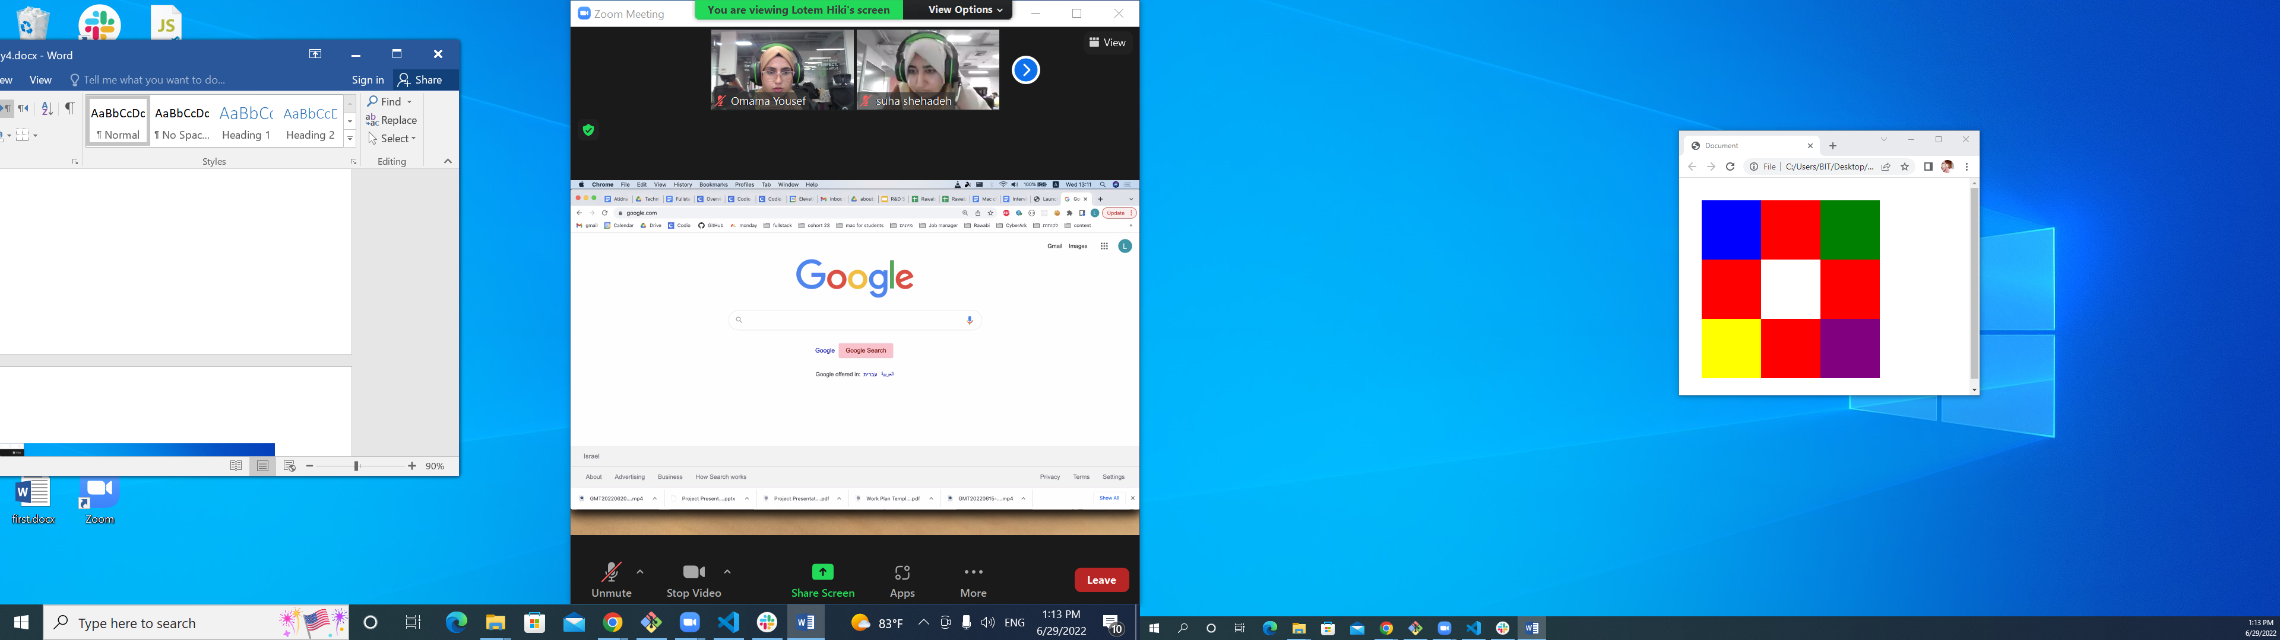



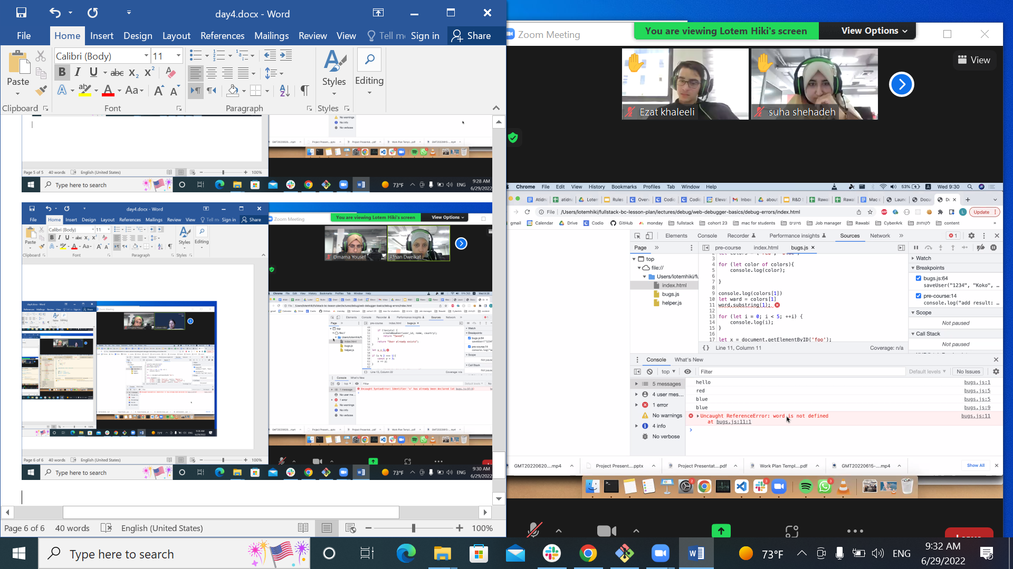

**Break down in the problem**

**Object**

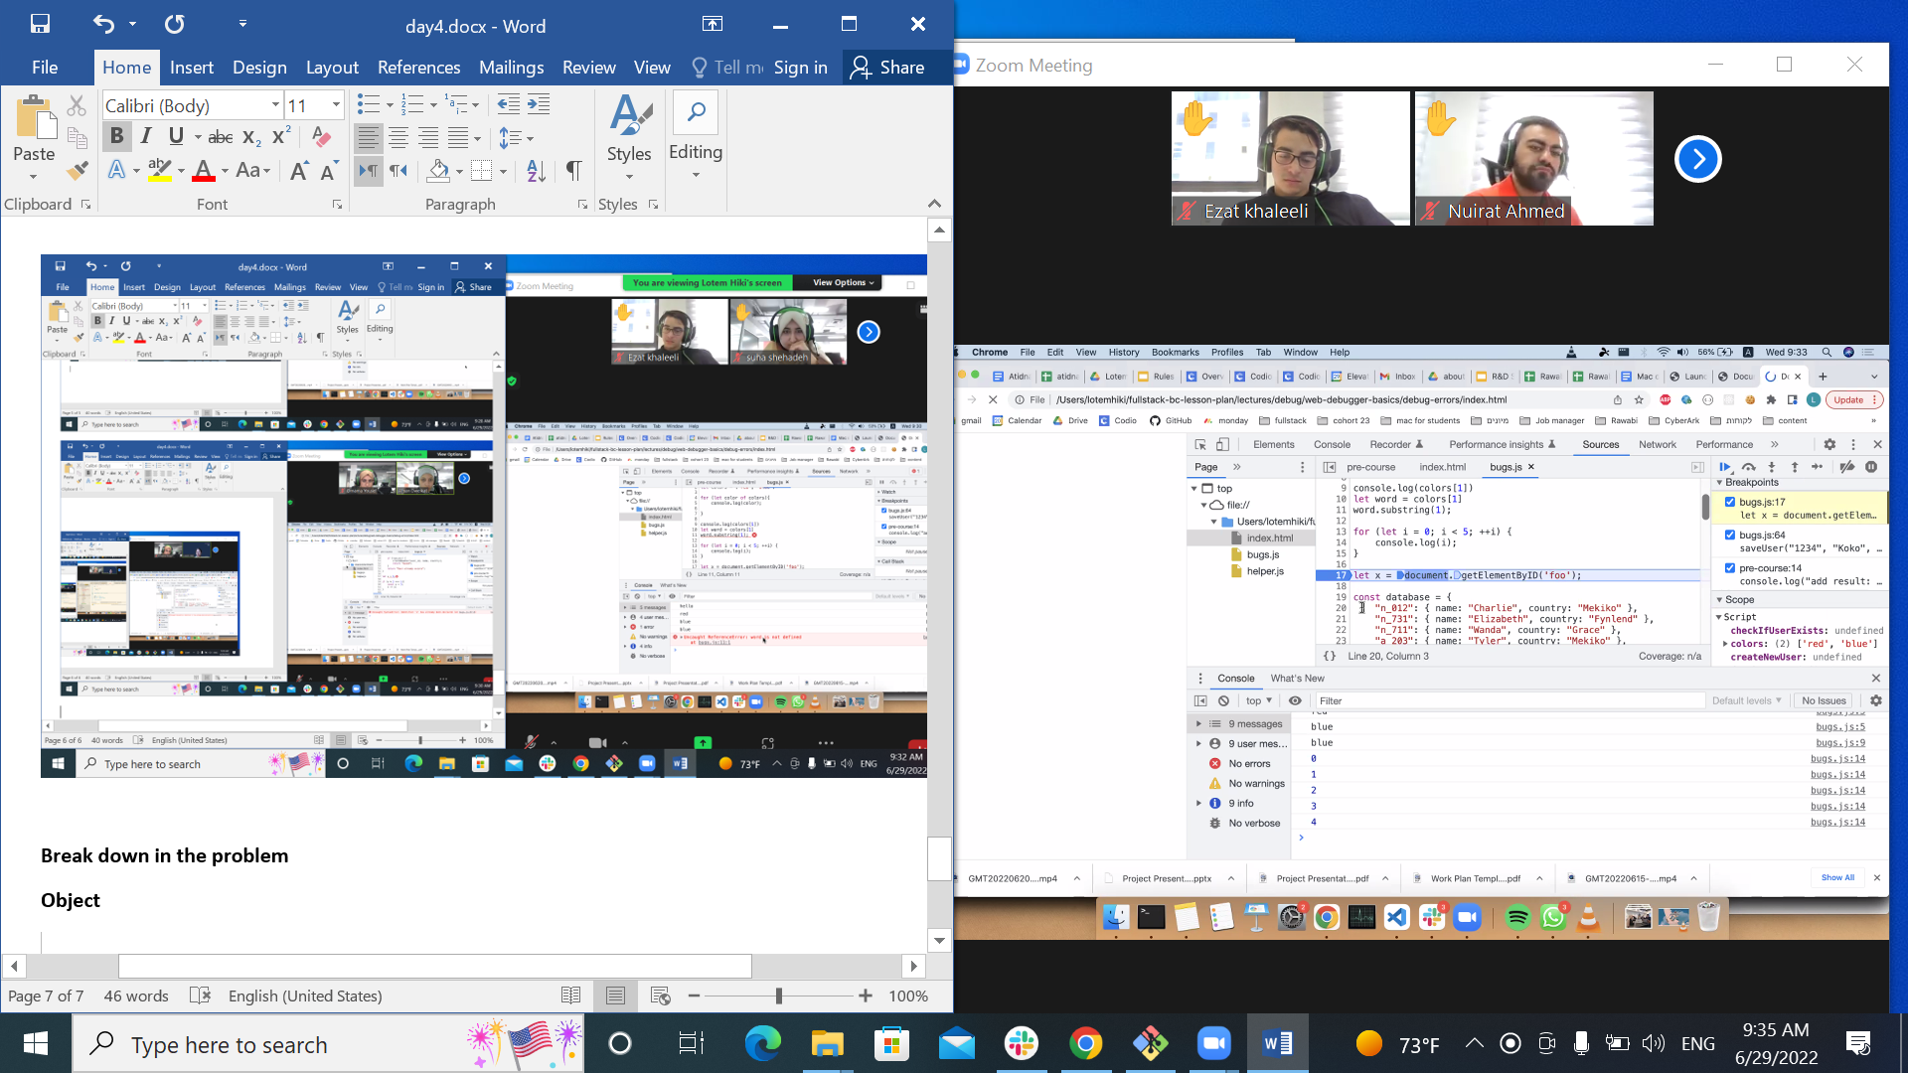

**It invoke**

**Object exist or not**

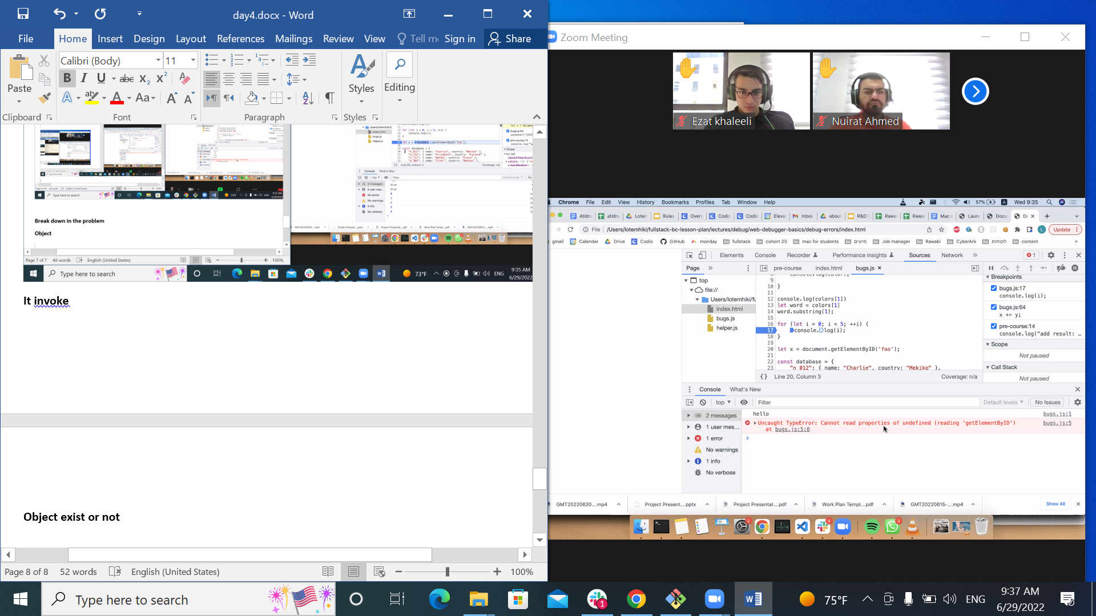

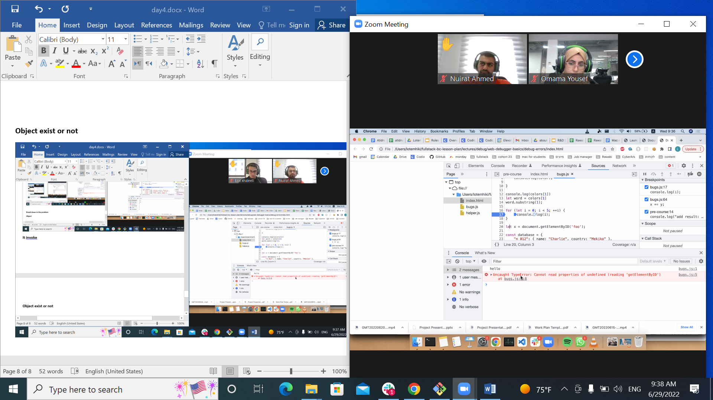

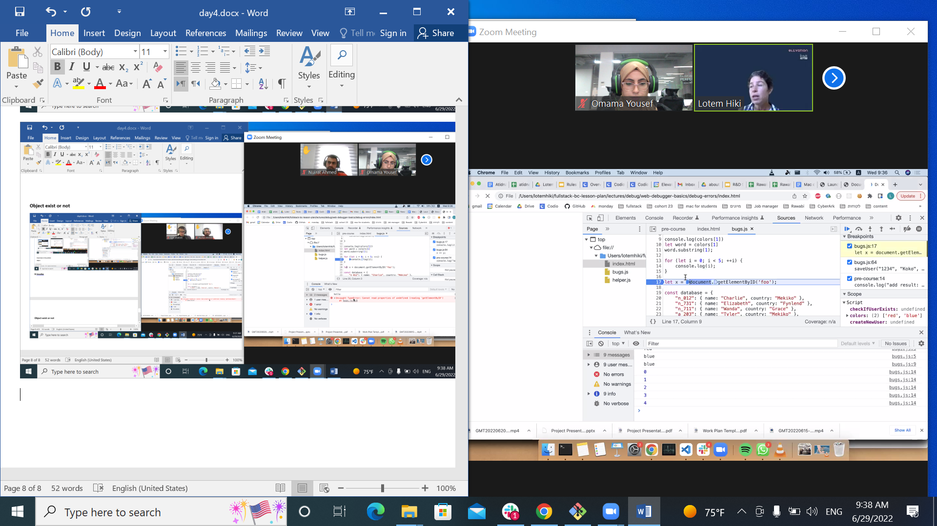

**Type when sth is obj, array…. Check …**

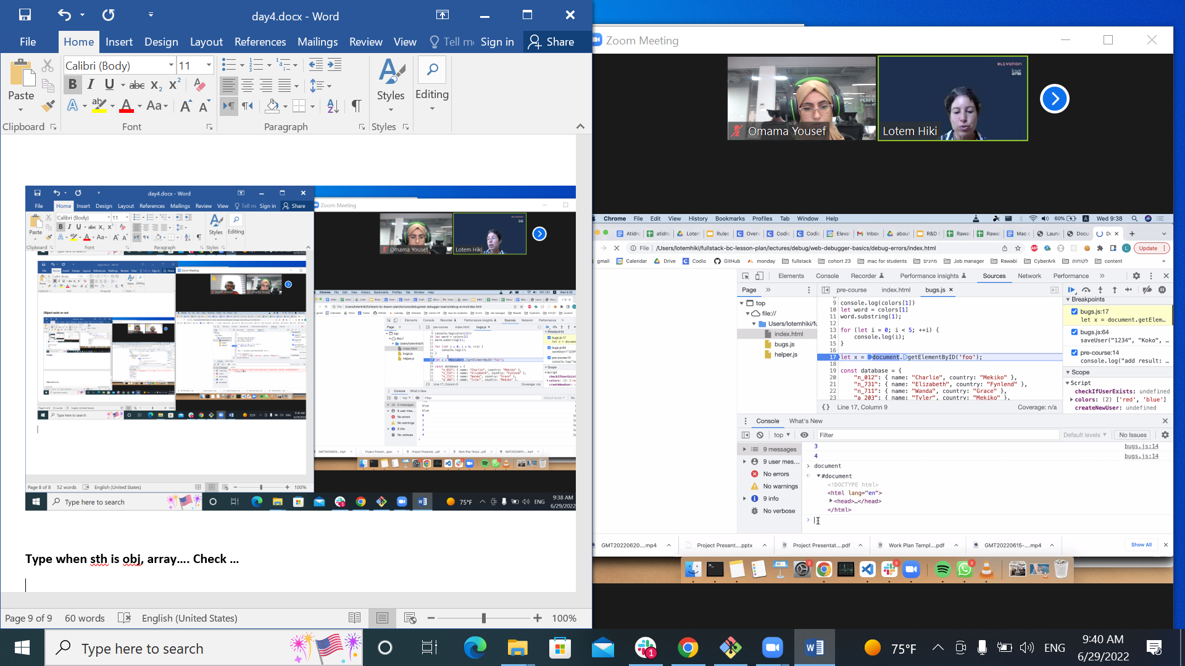

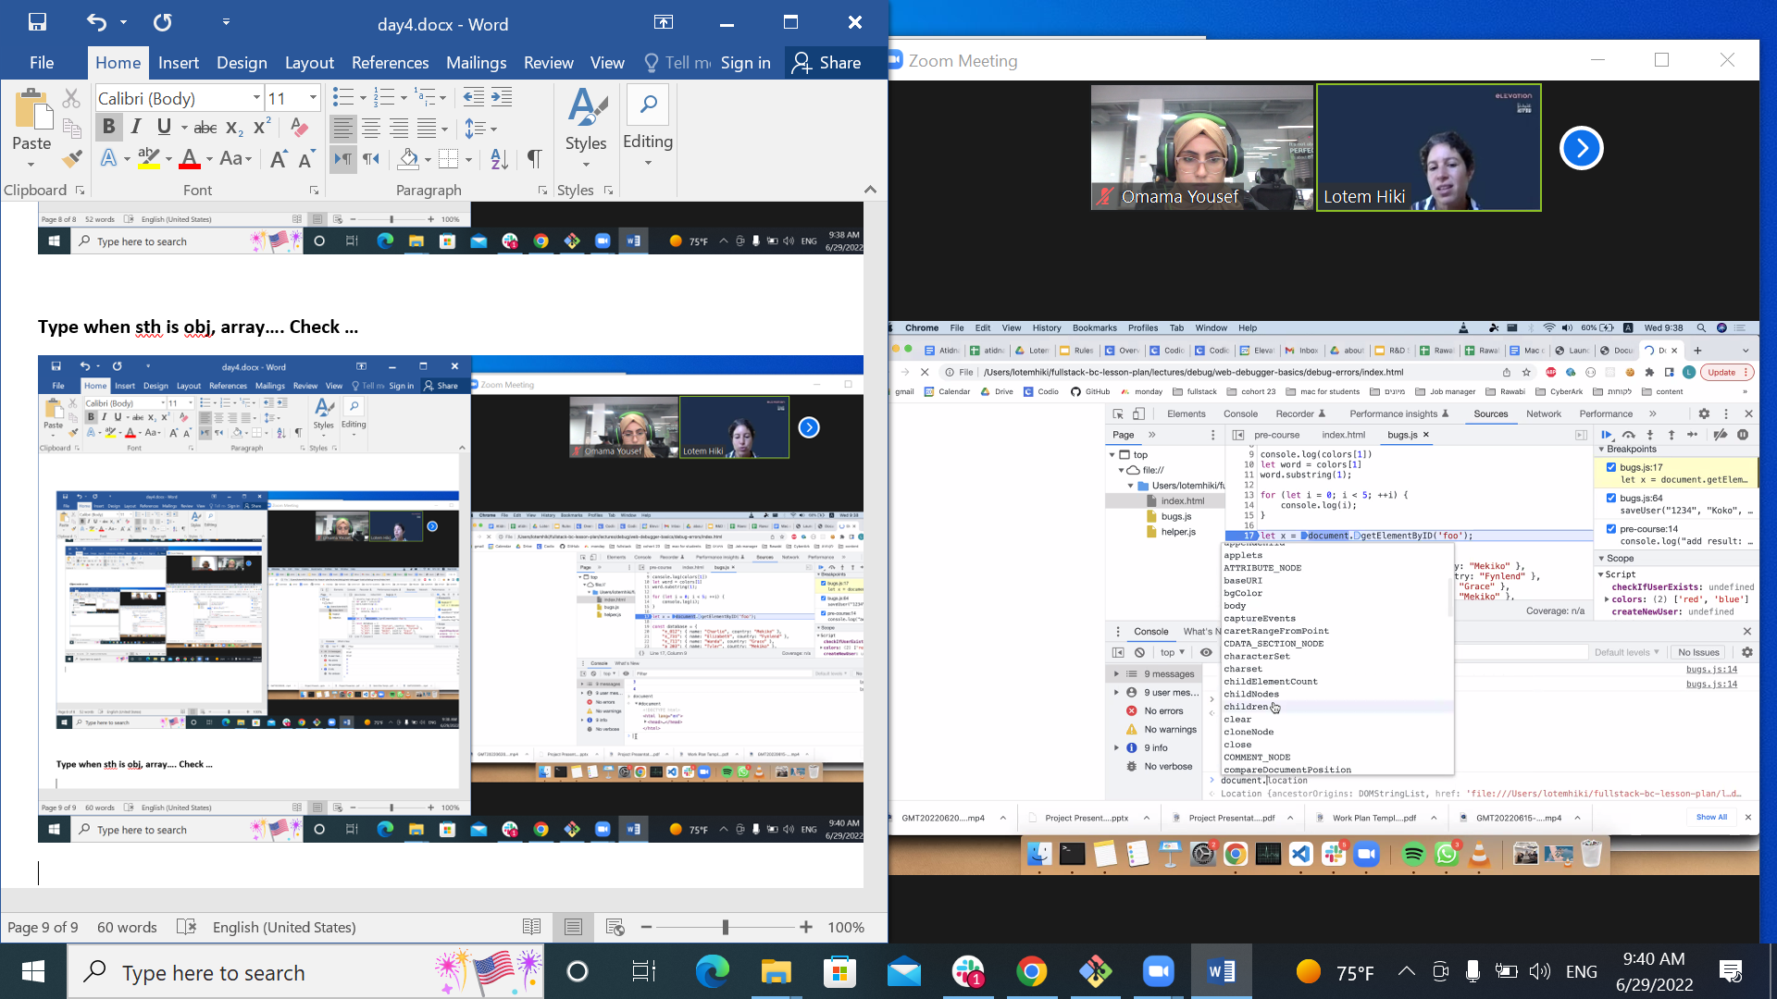

**Undefine what it mean??**

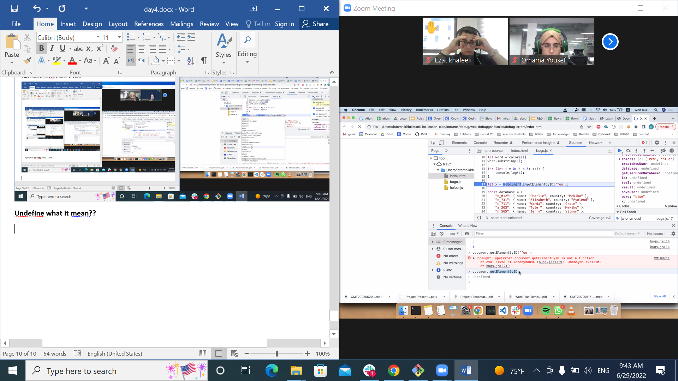

**Skill of the debugging**

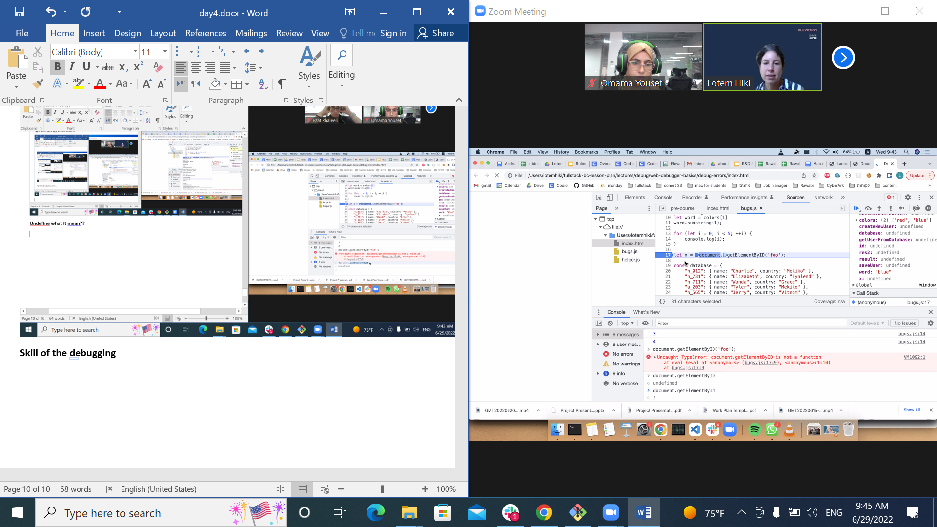

**Un the camel alphabet**

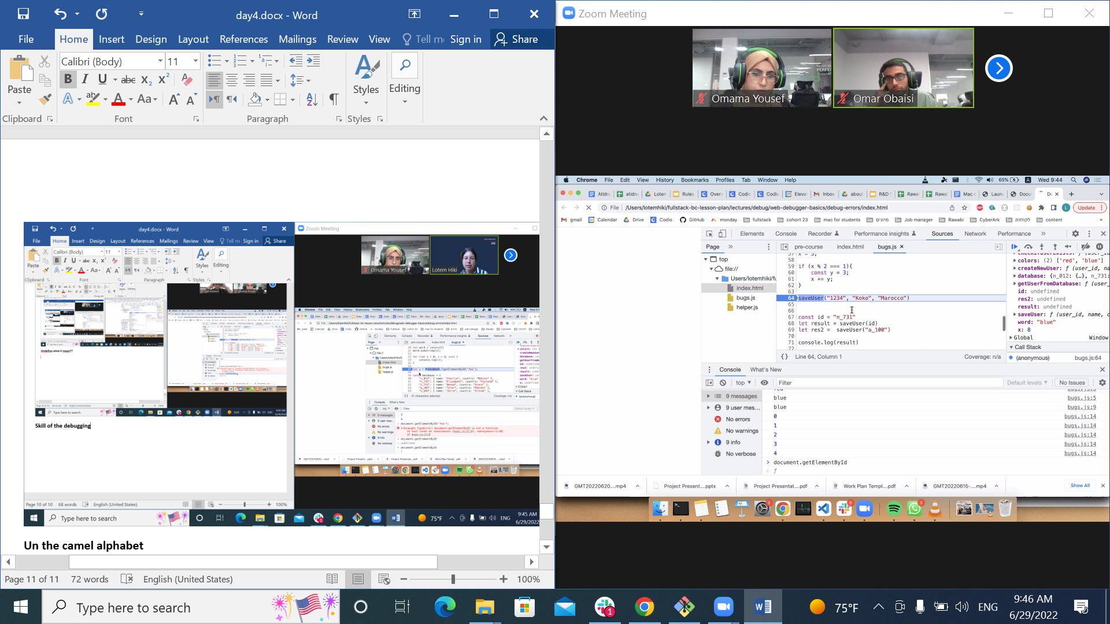

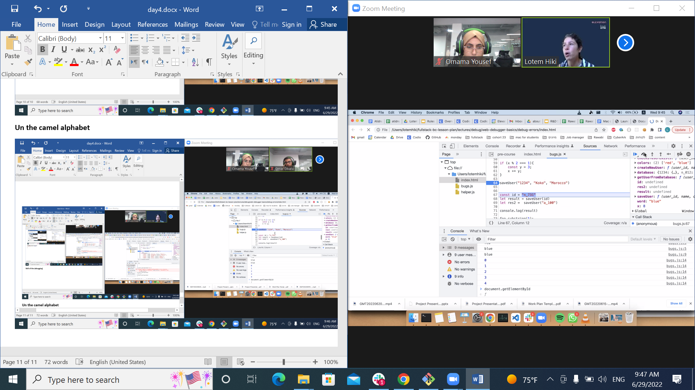

**Beacause the break statement**

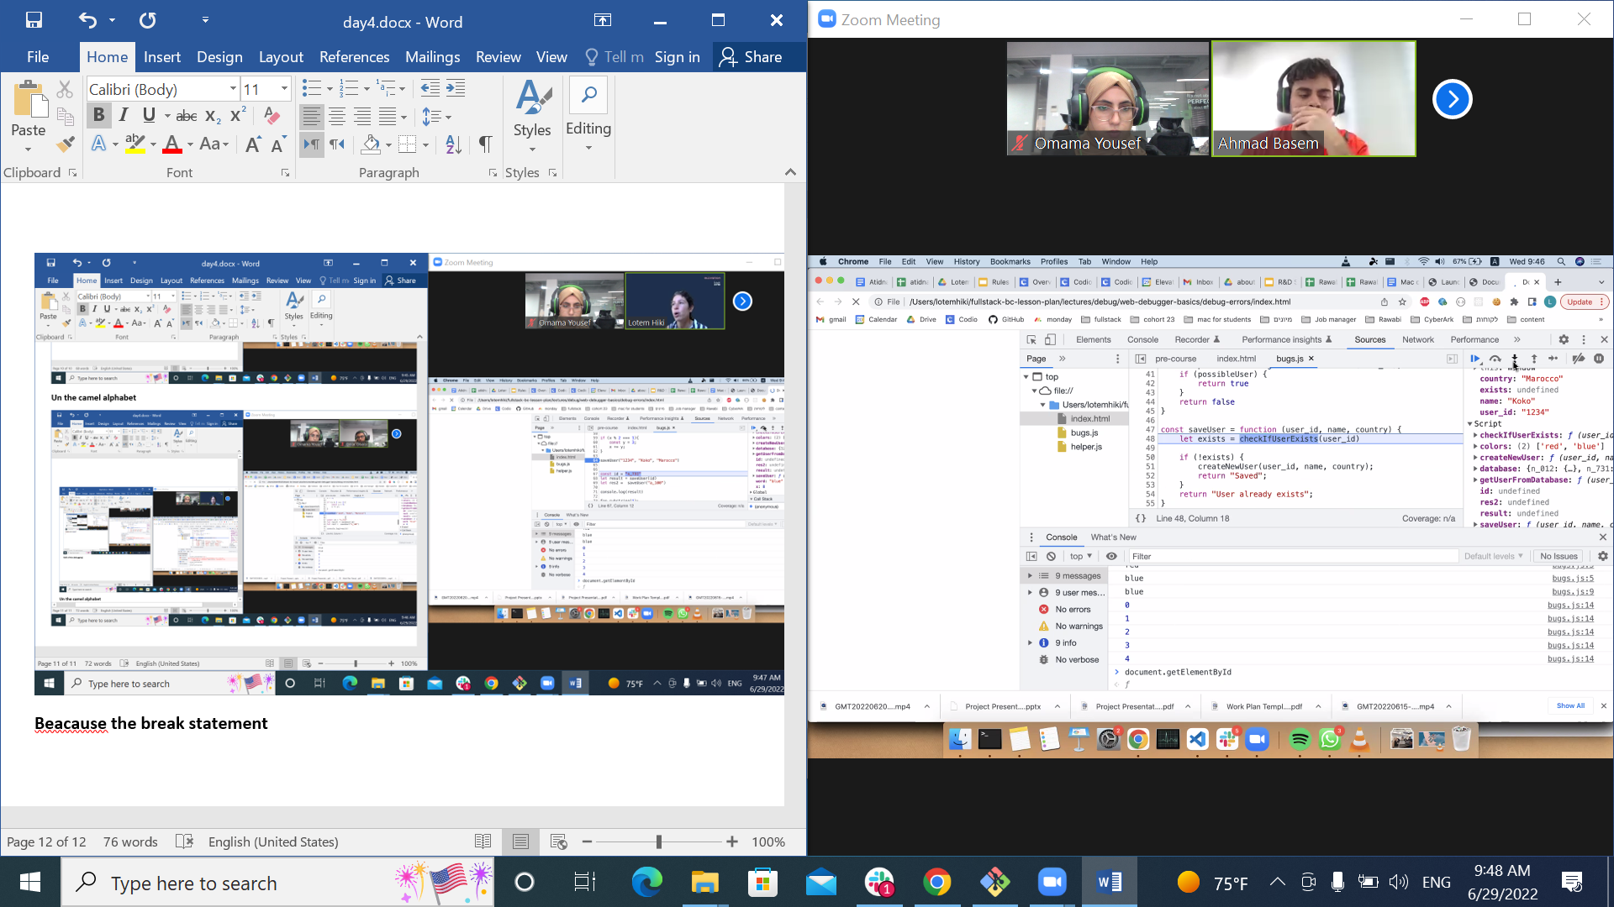

**Excecte the code yes but not بنفذو بس الكديبغر بفشق عنو على شان السرعة**

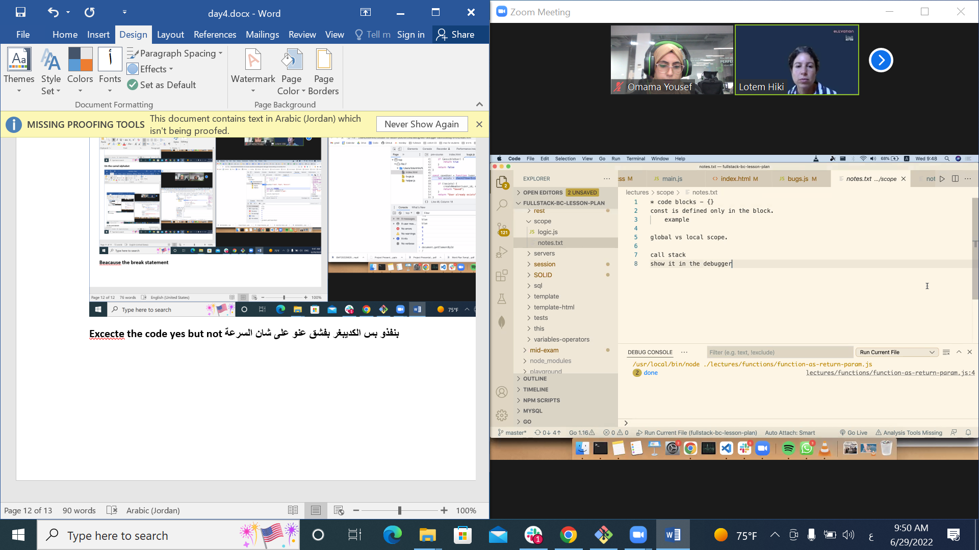

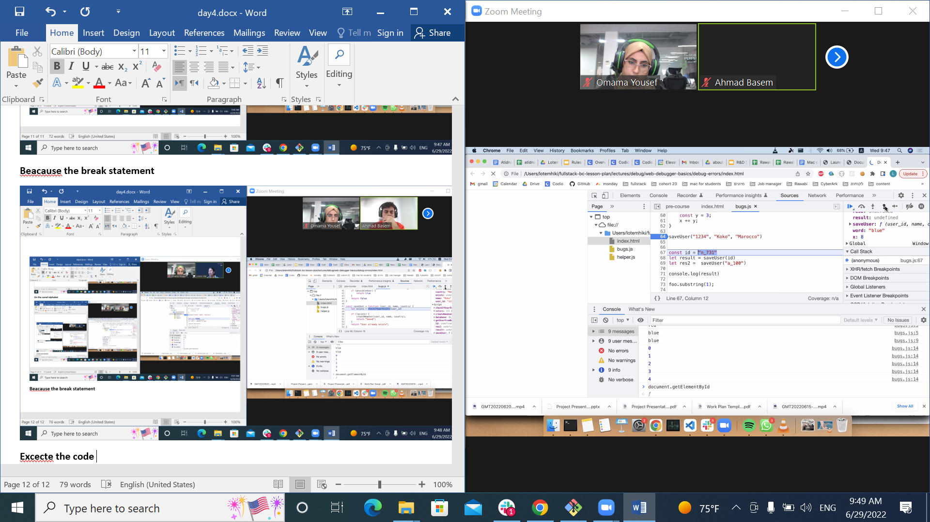

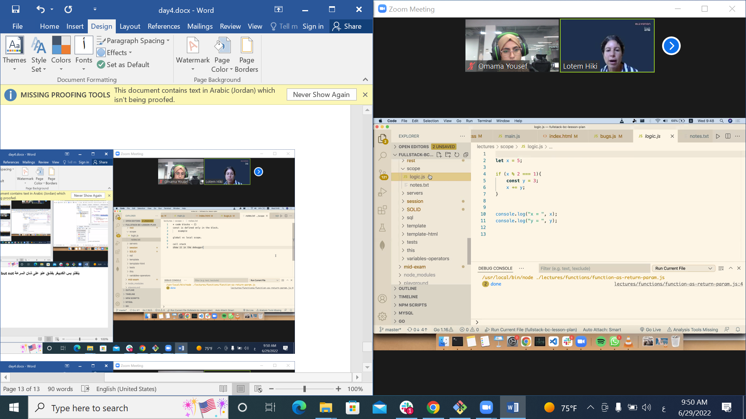

**Let eassign**

**Variable**

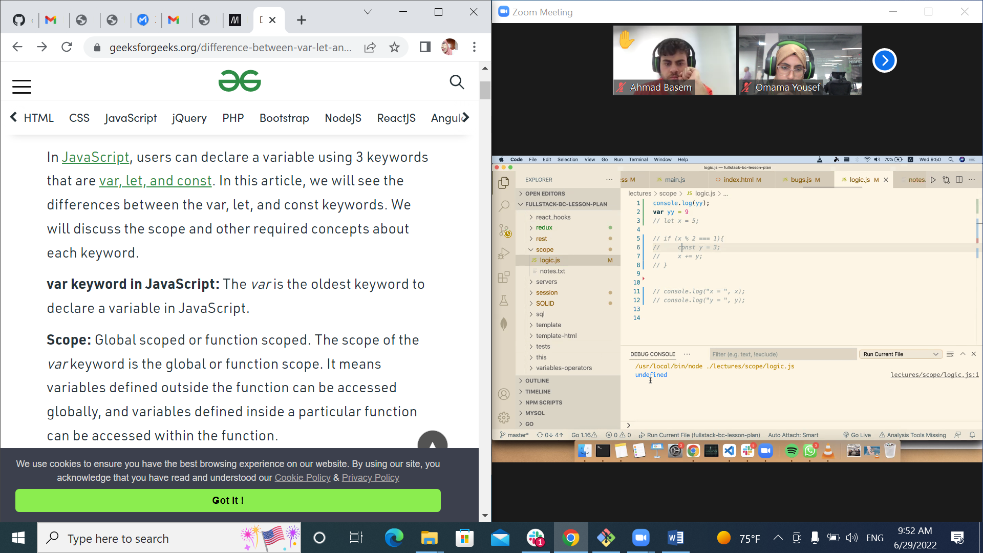

[**https://www.geeksforgeeks.org/difference-between-var-let-and-const-keywords-in-javascript/**](https://www.geeksforgeeks.org/difference-between-var-let-and-const-keywords-in-javascript/)

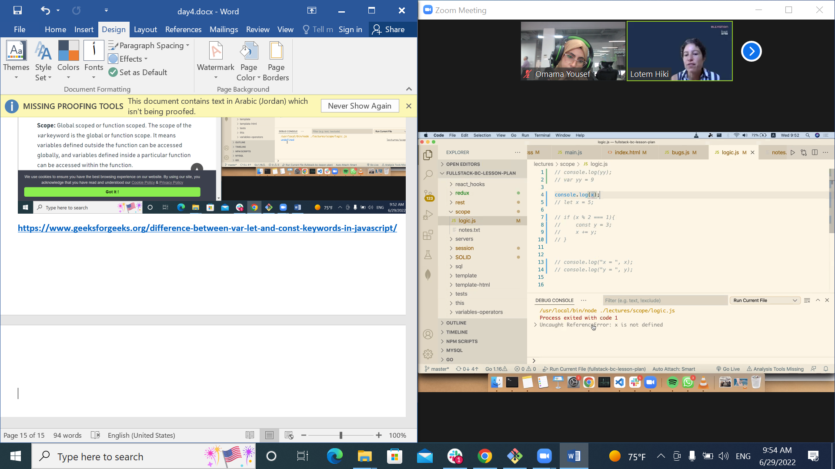

**Undefined heeek**

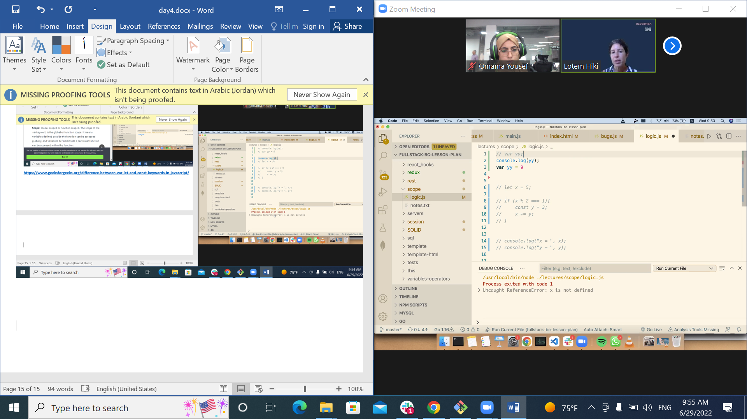

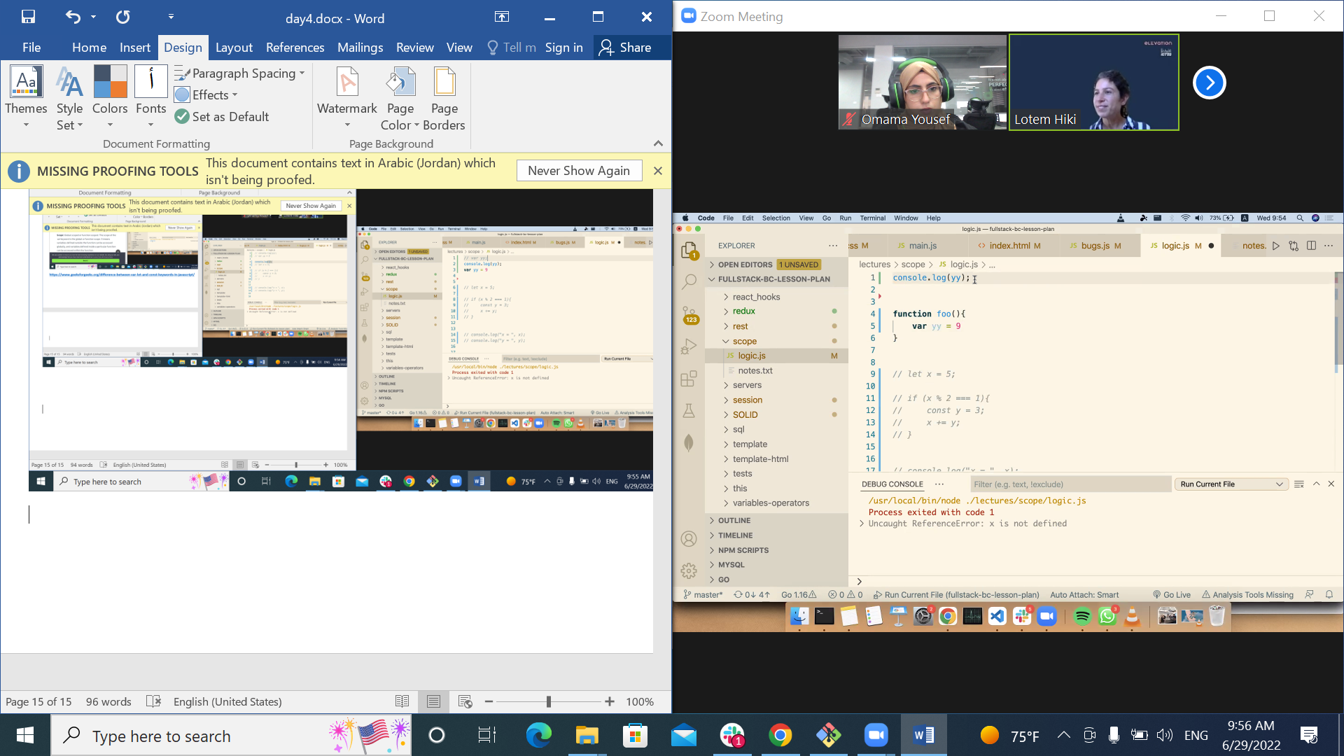

**Hoising???????**

**Redeclarable……….**

**لازم تنتبهي لل سكوب وكمان نعريفاتهم مو بس اكس**

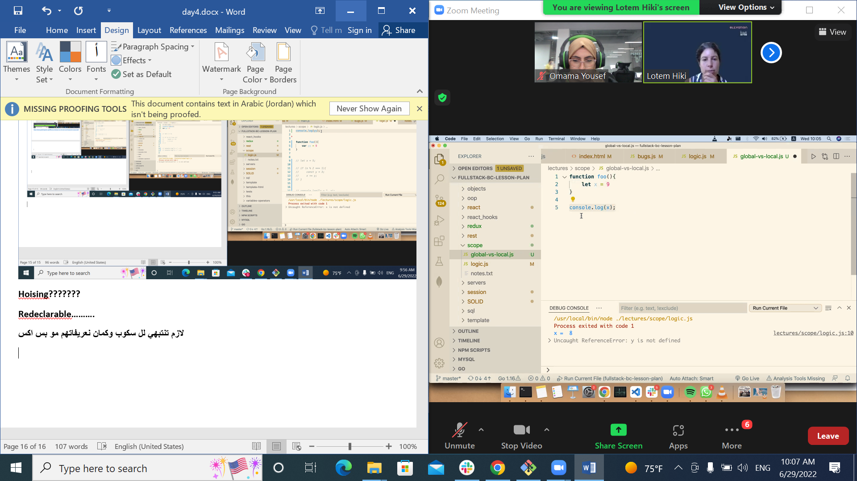

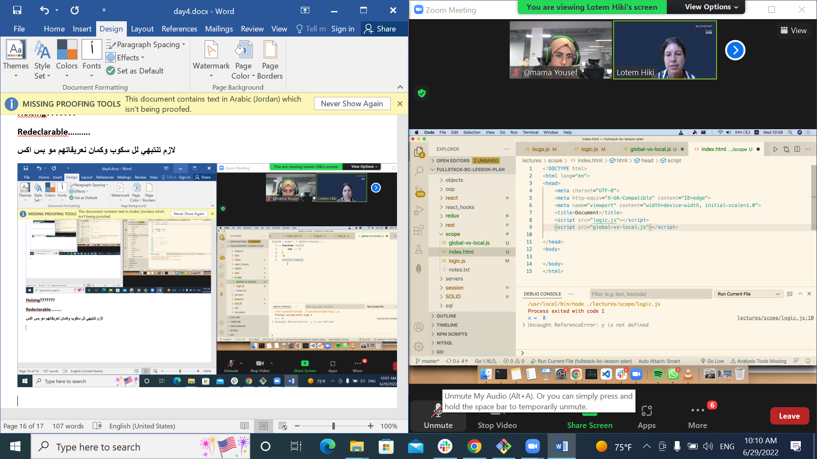

**Can I share variable from two file?**

**It depends to the order**

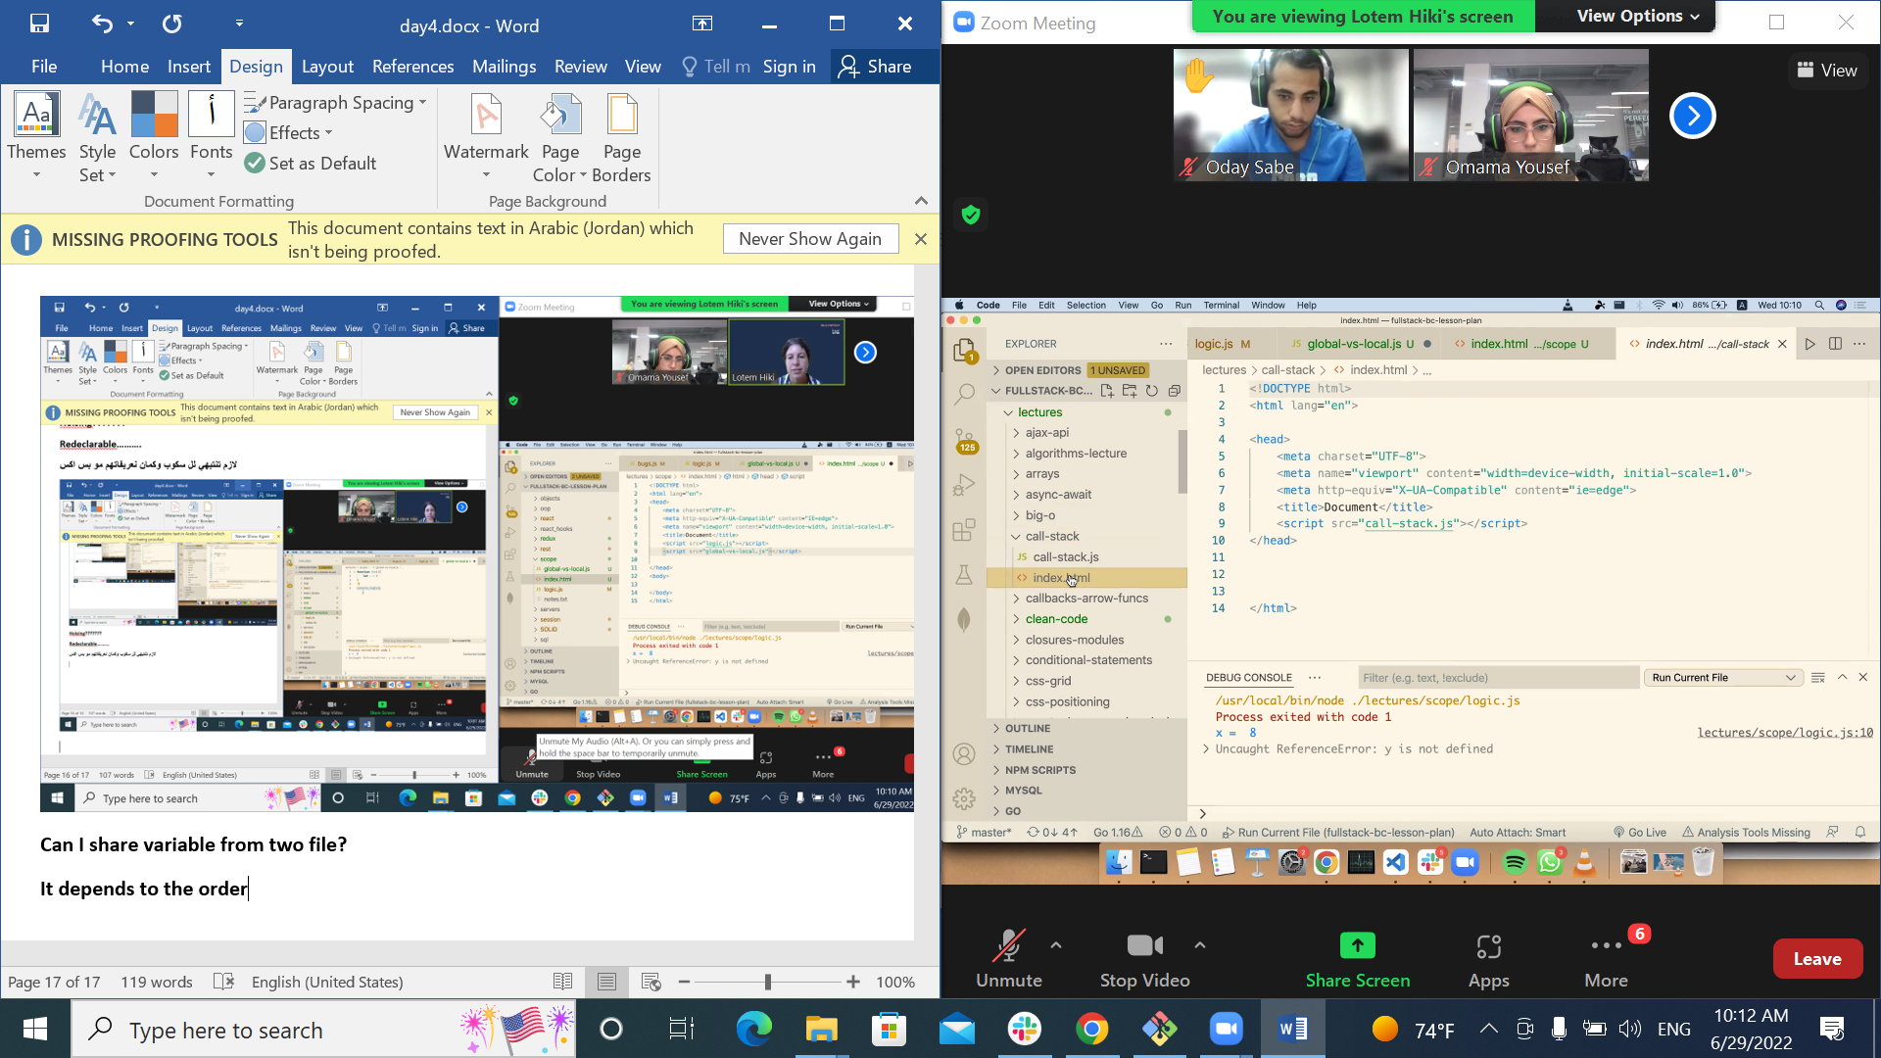

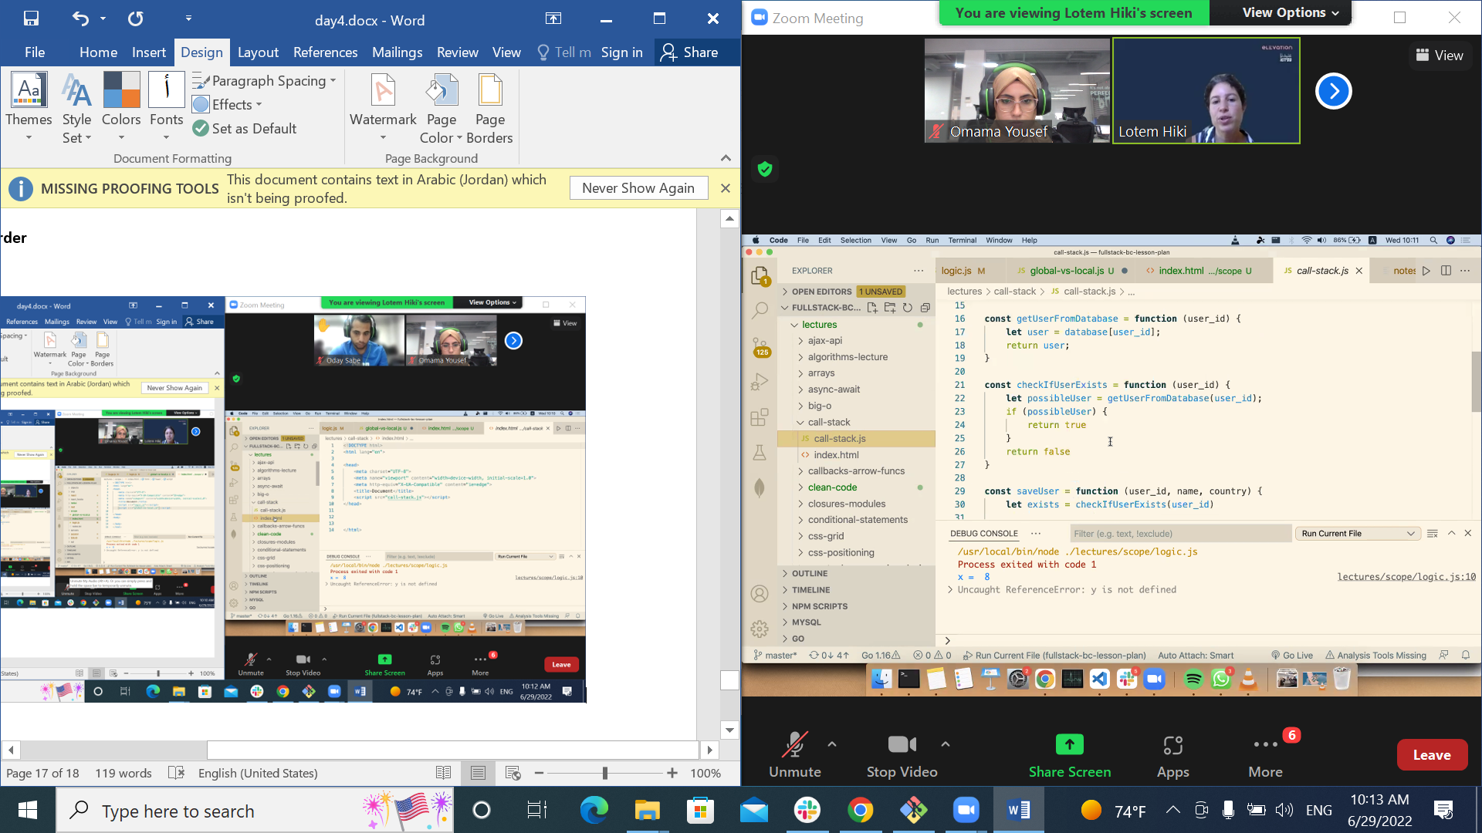

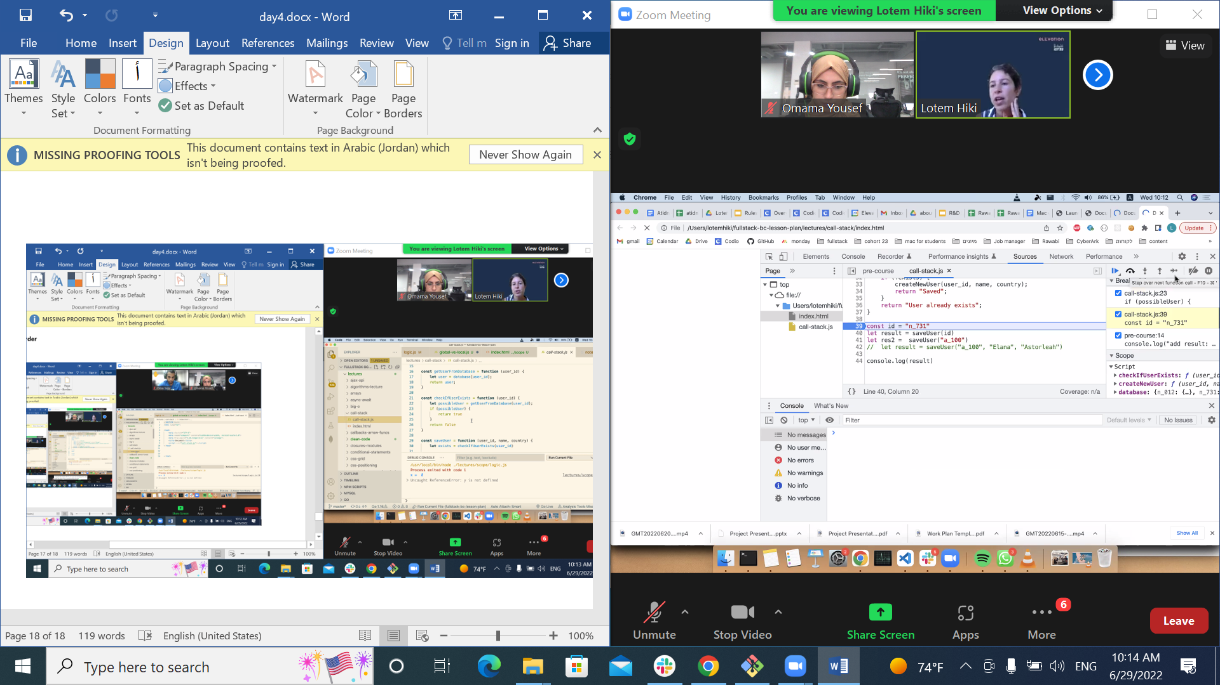

**Step into**

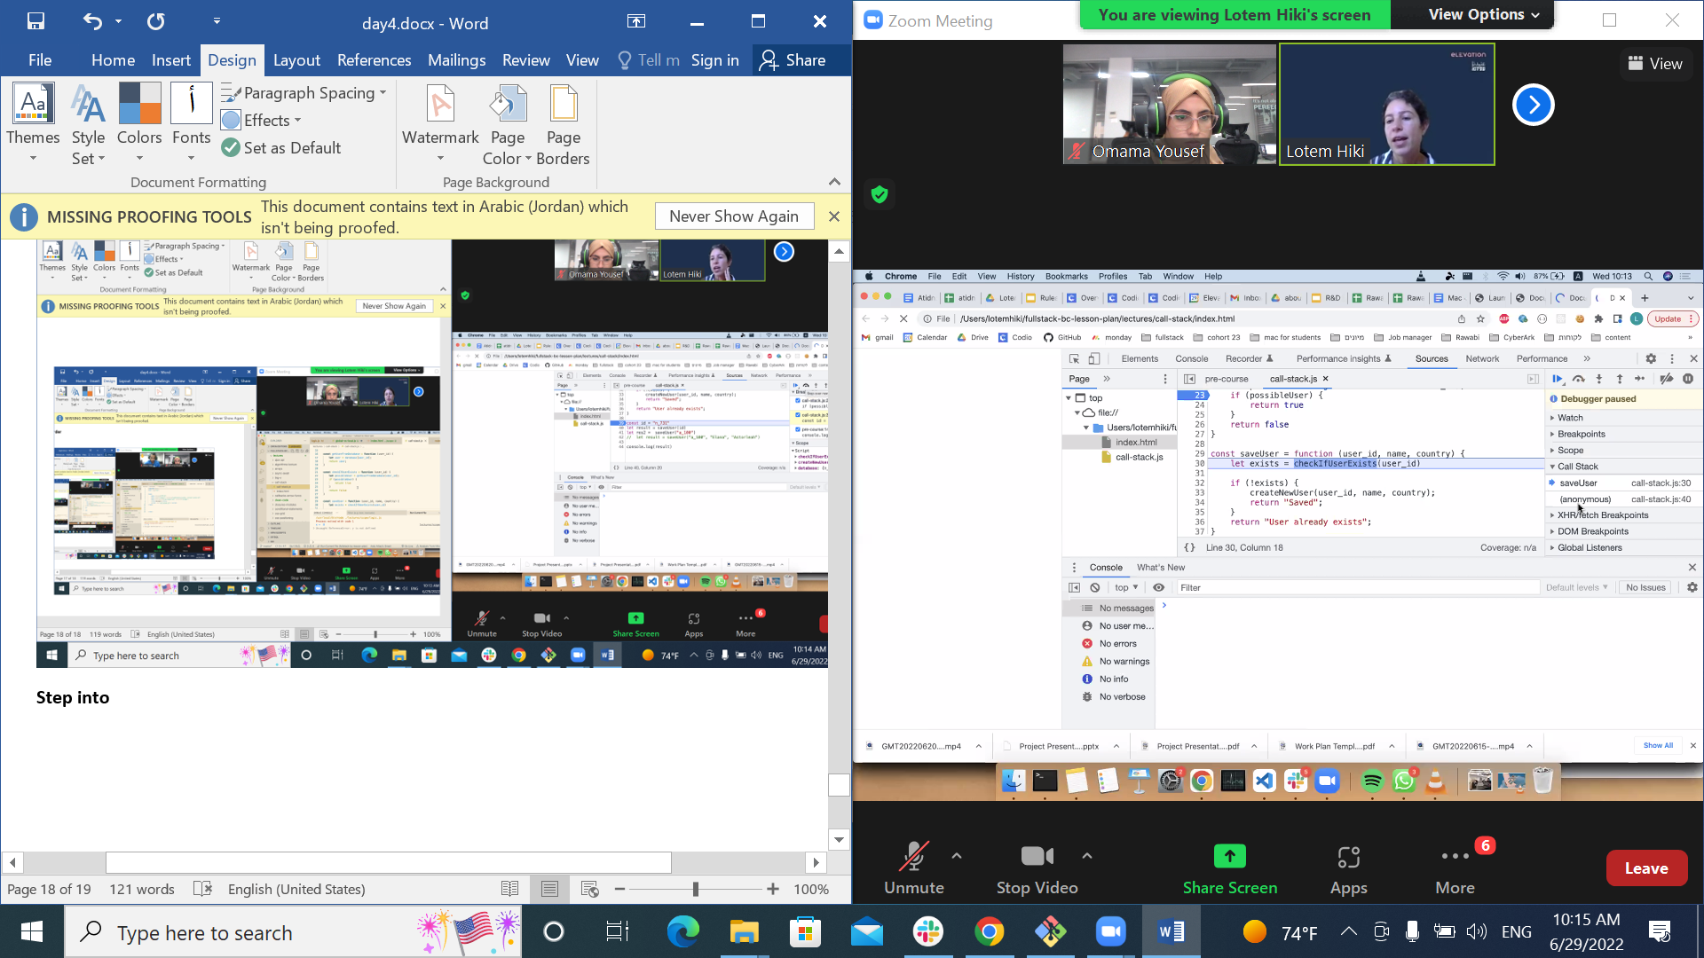

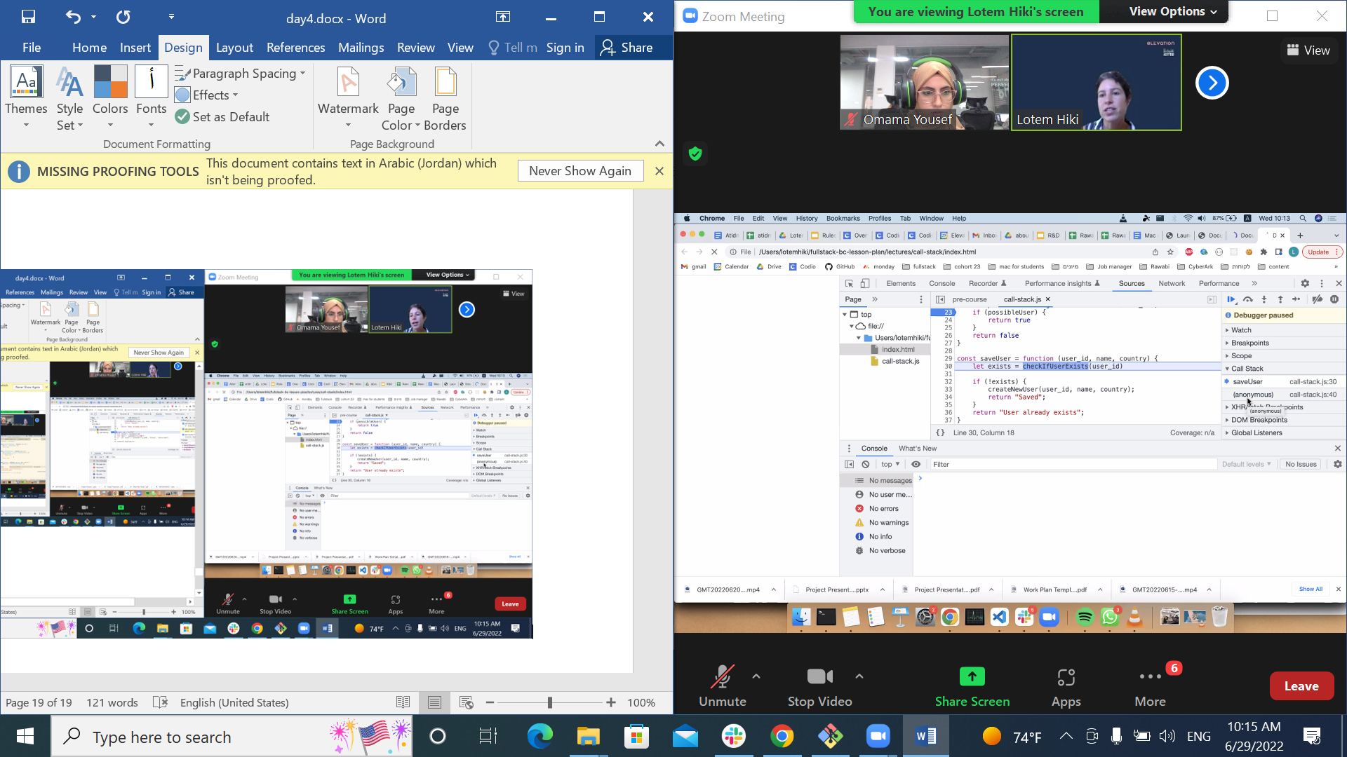

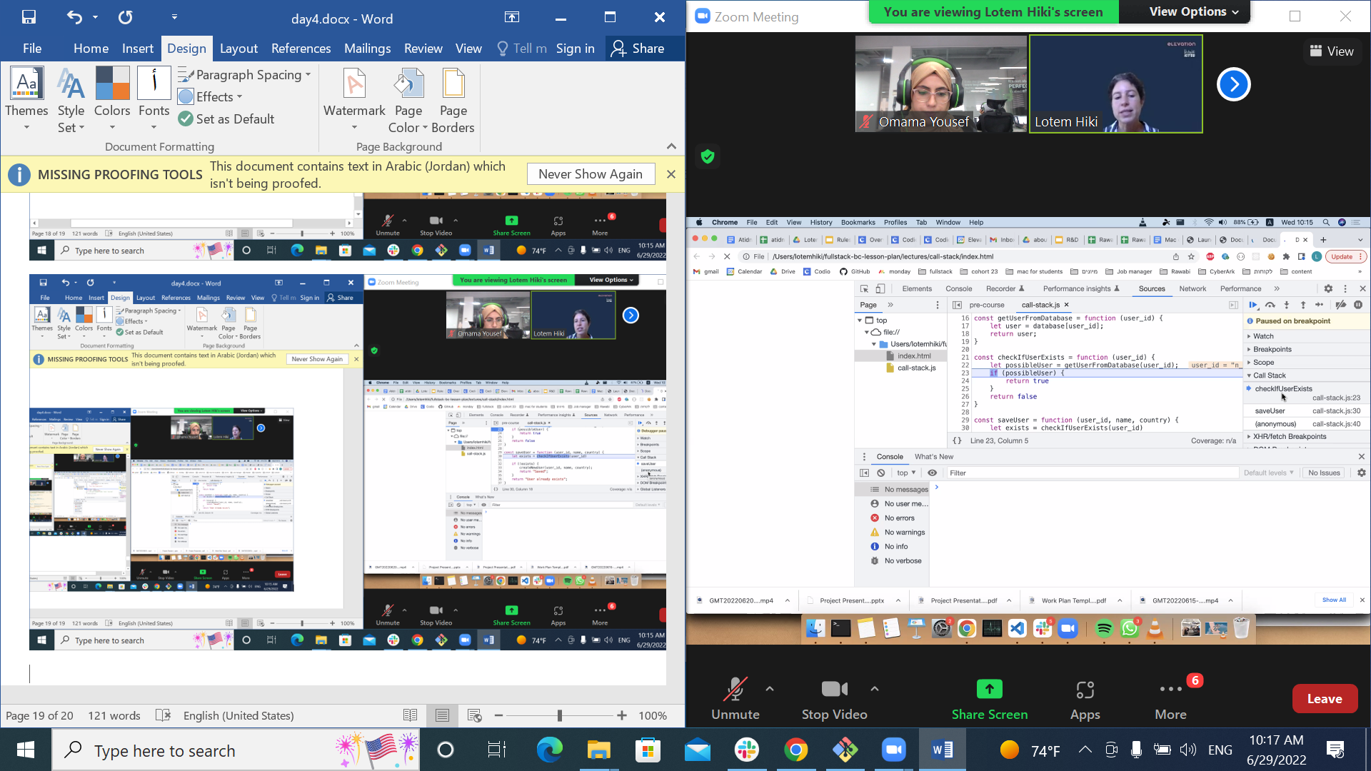

**Call stack**

**\***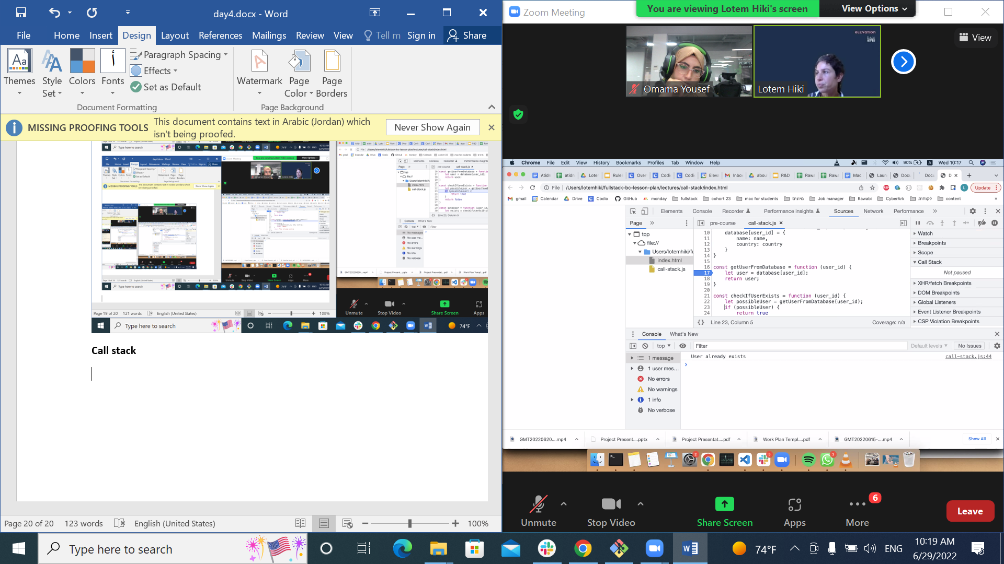

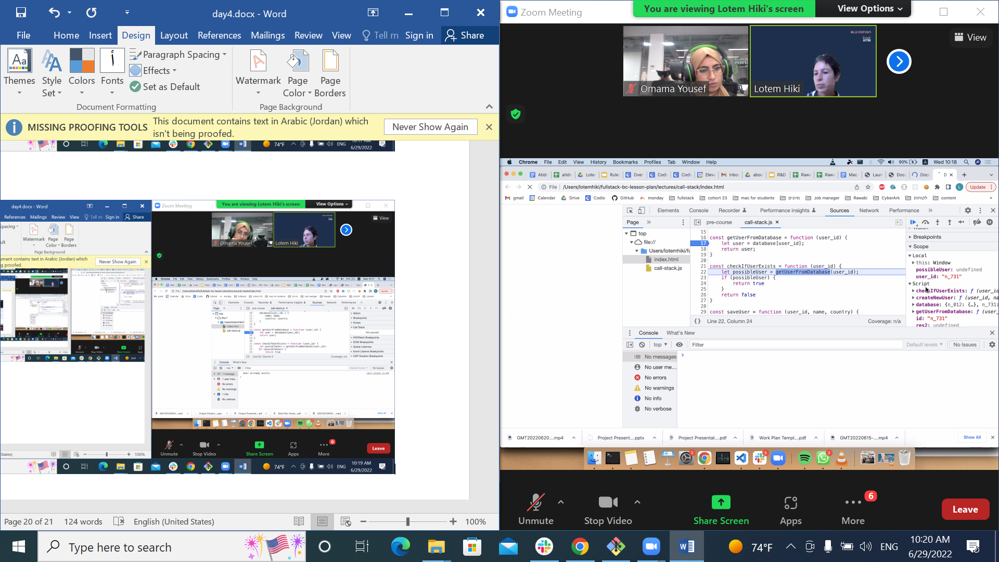

**اهم اشي التووولز والبرنسبلز**

**­**

**How many time foo function**

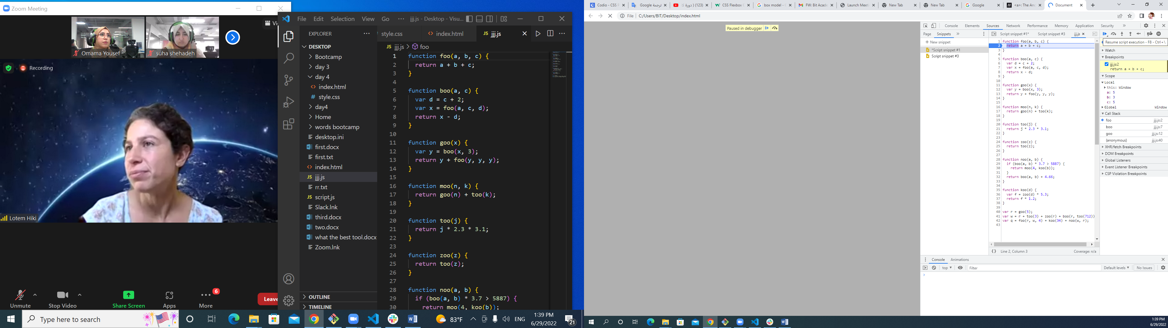

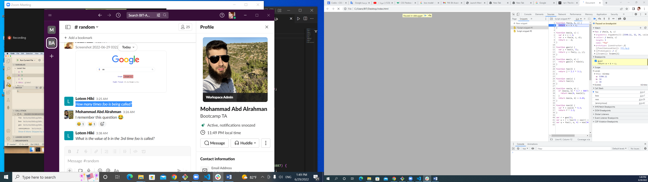

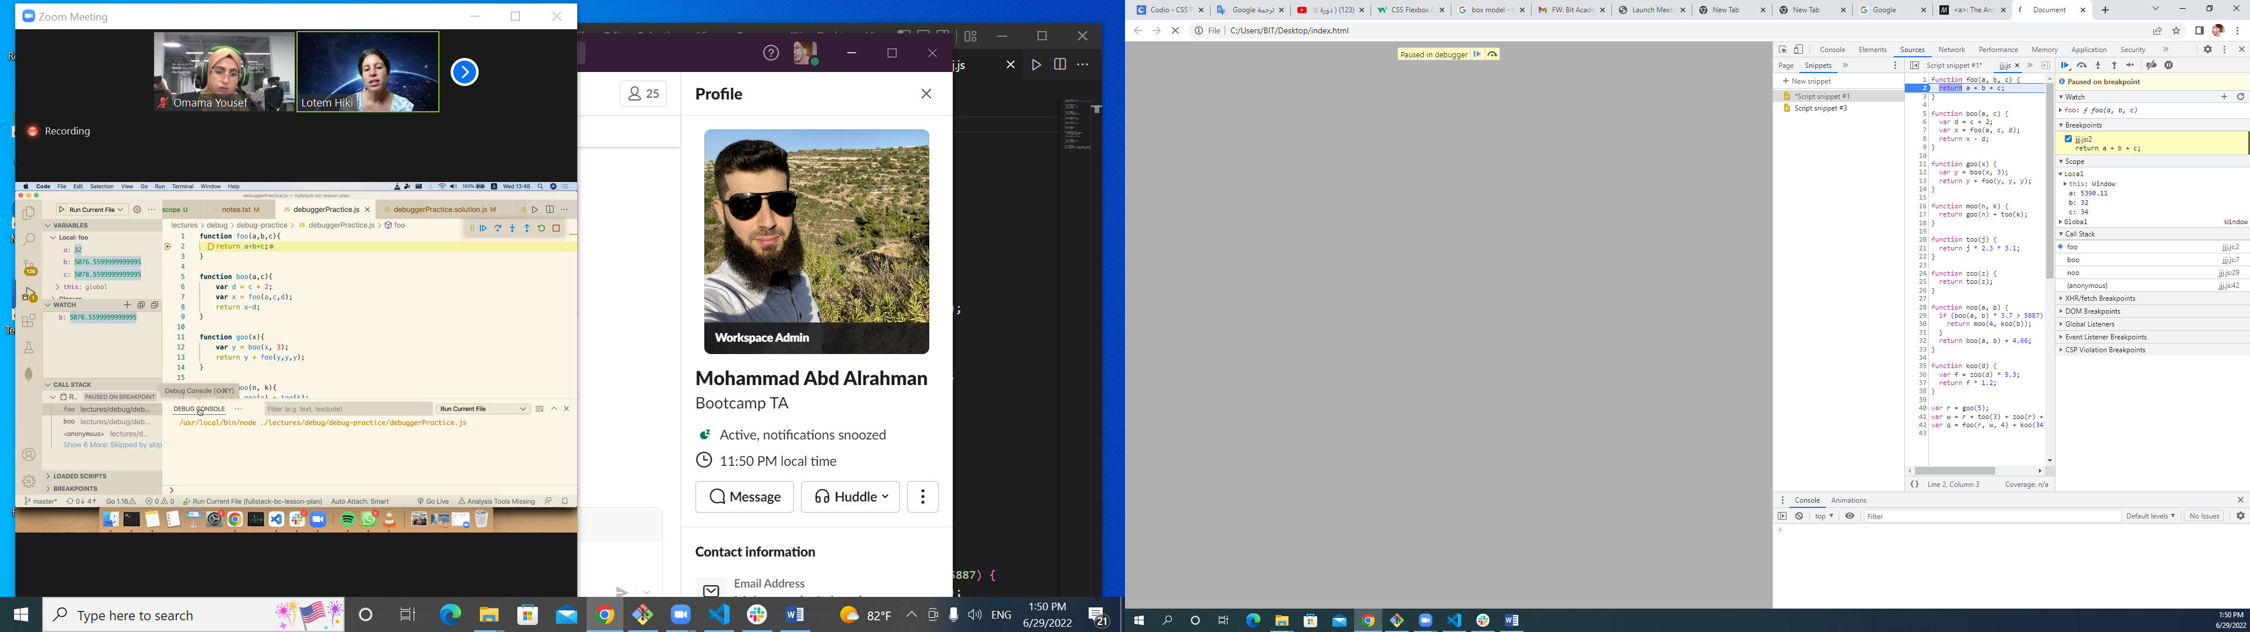

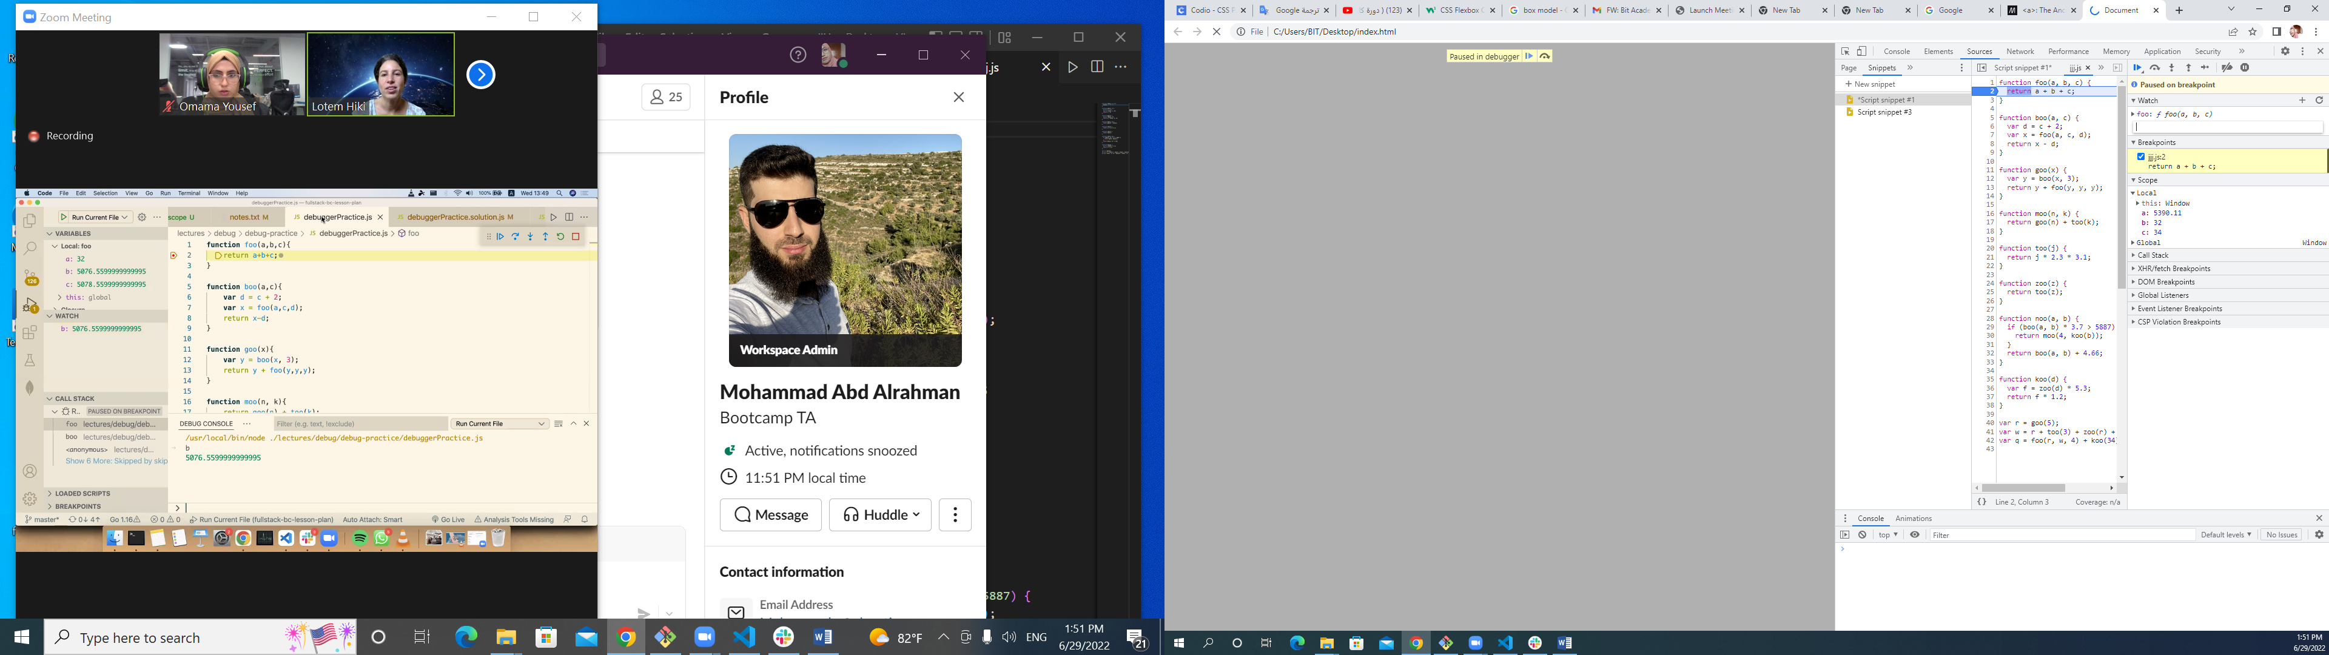

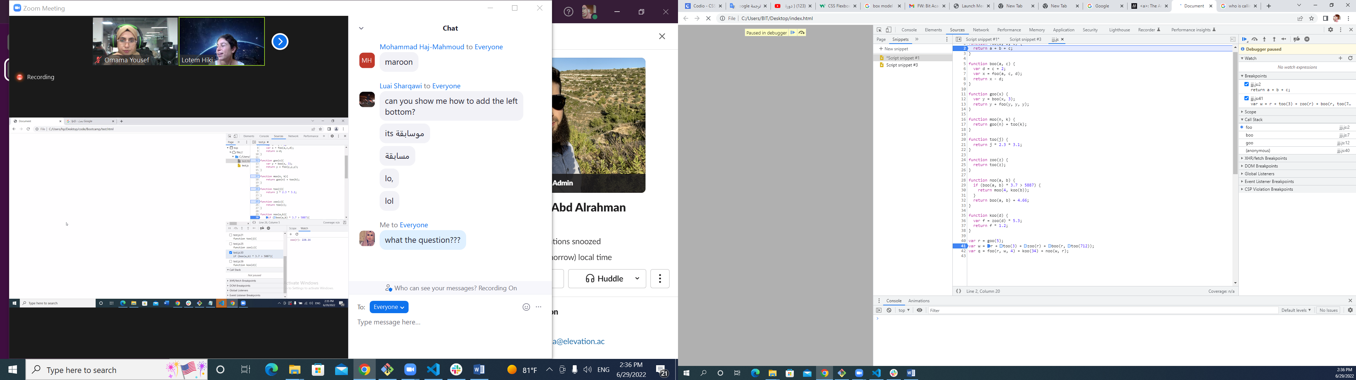

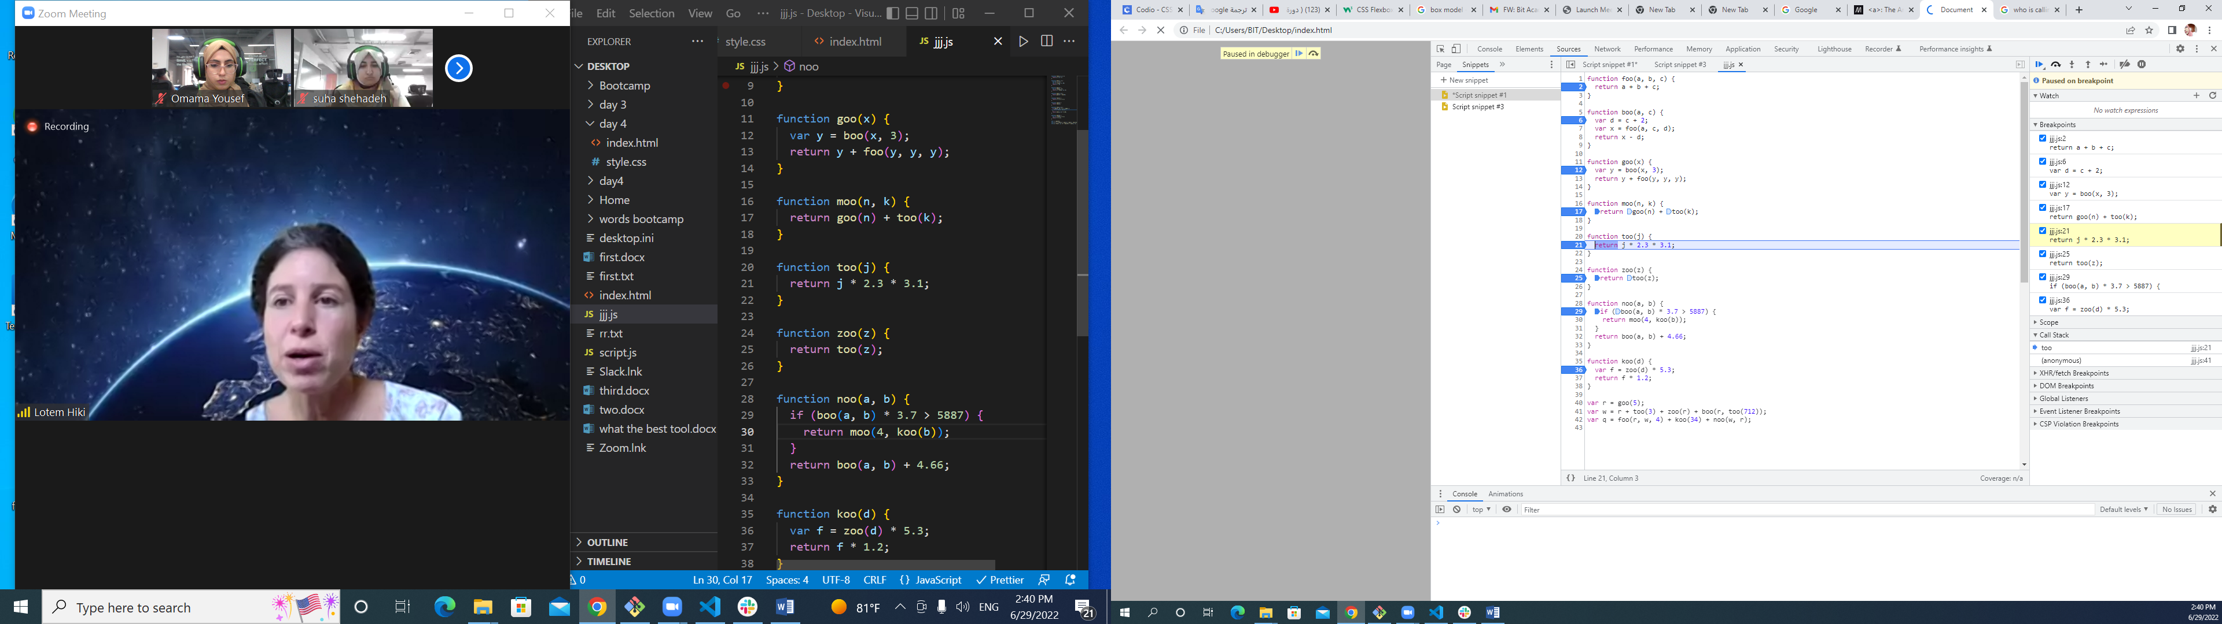

[**otem Hiki**](https://app.slack.com/team/U03KMFGQFDG)  [3:38 AM](https://bitacademy-elevation.slack.com/archives/C03KESUSEES/p1656499126287459)

*What is the value of b in the 3rd time foo is called?*



[**Lotem Hiki**](https://app.slack.com/team/U03KMFGQFDG)  [3:50 AM](https://bitacademy-elevation.slack.com/archives/C03KESUSEES/p1656499853608009)

*who is calling too the second time?*



[**Lotem Hiki**](https://app.slack.com/team/U03KMFGQFDG)  [3:58 AM](https://bitacademy-elevation.slack.com/archives/C03KESUSEES/p1656500320620619)

*what is the return value of zoo(r) when we calculate variable w?* (edited)





[**Lotem Hiki**](https://app.slack.com/team/U03KMFGQFDG)  [4:16 AM](https://bitacademy-elevation.slack.com/archives/C03KESUSEES/p1656501415988069)

*is there any function that is not called at all?*



[**Lotem Hiki**](https://app.slack.com/team/U03KMFGQFDG)  [4:39 AM](https://bitacademy-elevation.slack.com/archives/C03KESUSEES/p1656502793725799)

*Who is calling foo the first time it is being called?what is the greatest value zoo sends as a parameter to too?what is the largest value of j*2.3 when calling too?*

*How many times foo is being called?*

function foo(a,b,c){

return a+b+c;

}

function boo(a,c){

var d = c + 2;

var x = foo(a,c,d);

return x-d;

}

function goo(x){

var y = boo(x, 3);

return y + foo(y,y,y);

}

function moo(n, k){

return goo(n) + too(k);

}

function too(j){

return j * 2.3 * 3.1;

}

function zoo(z){

return too(z);

}

function noo(a,b){

if (boo(a,b) * 3.7 > 5887){

return moo(4, koo(b));

}

return boo(a,b) + 4.66;

}

function koo(d){

var f = zoo(d) * 5.3;

return f * 1.2;

}

var r = goo(5);

var w = r + too(3) + zoo(r) + boo(r, too(712));

var q = foo(r, w, 4) + koo(34) + noo(w,r);

